**SHIPPING DATA ANALYSIS**

* Open the Power BI Desktop application, and in the Report View, import the Shipping Data from Excel Workbook option present under the Home tab.

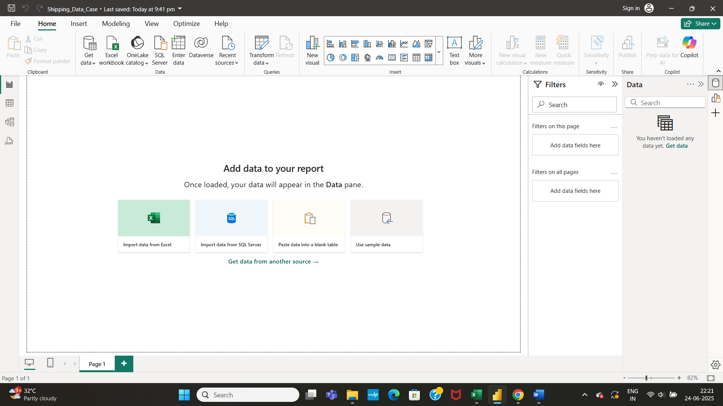

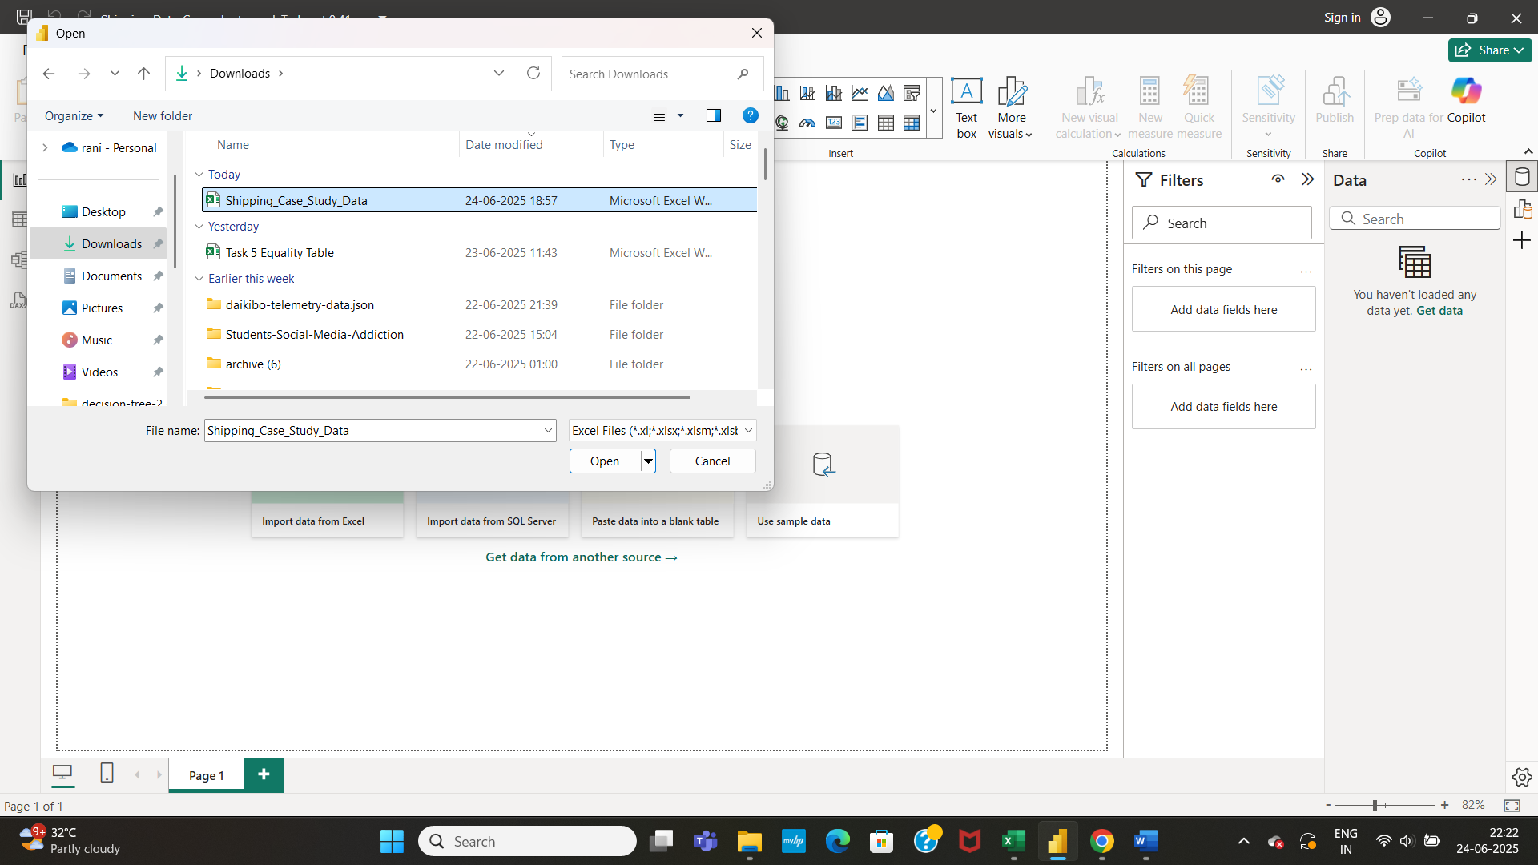

* Check for the required columns present and load the data

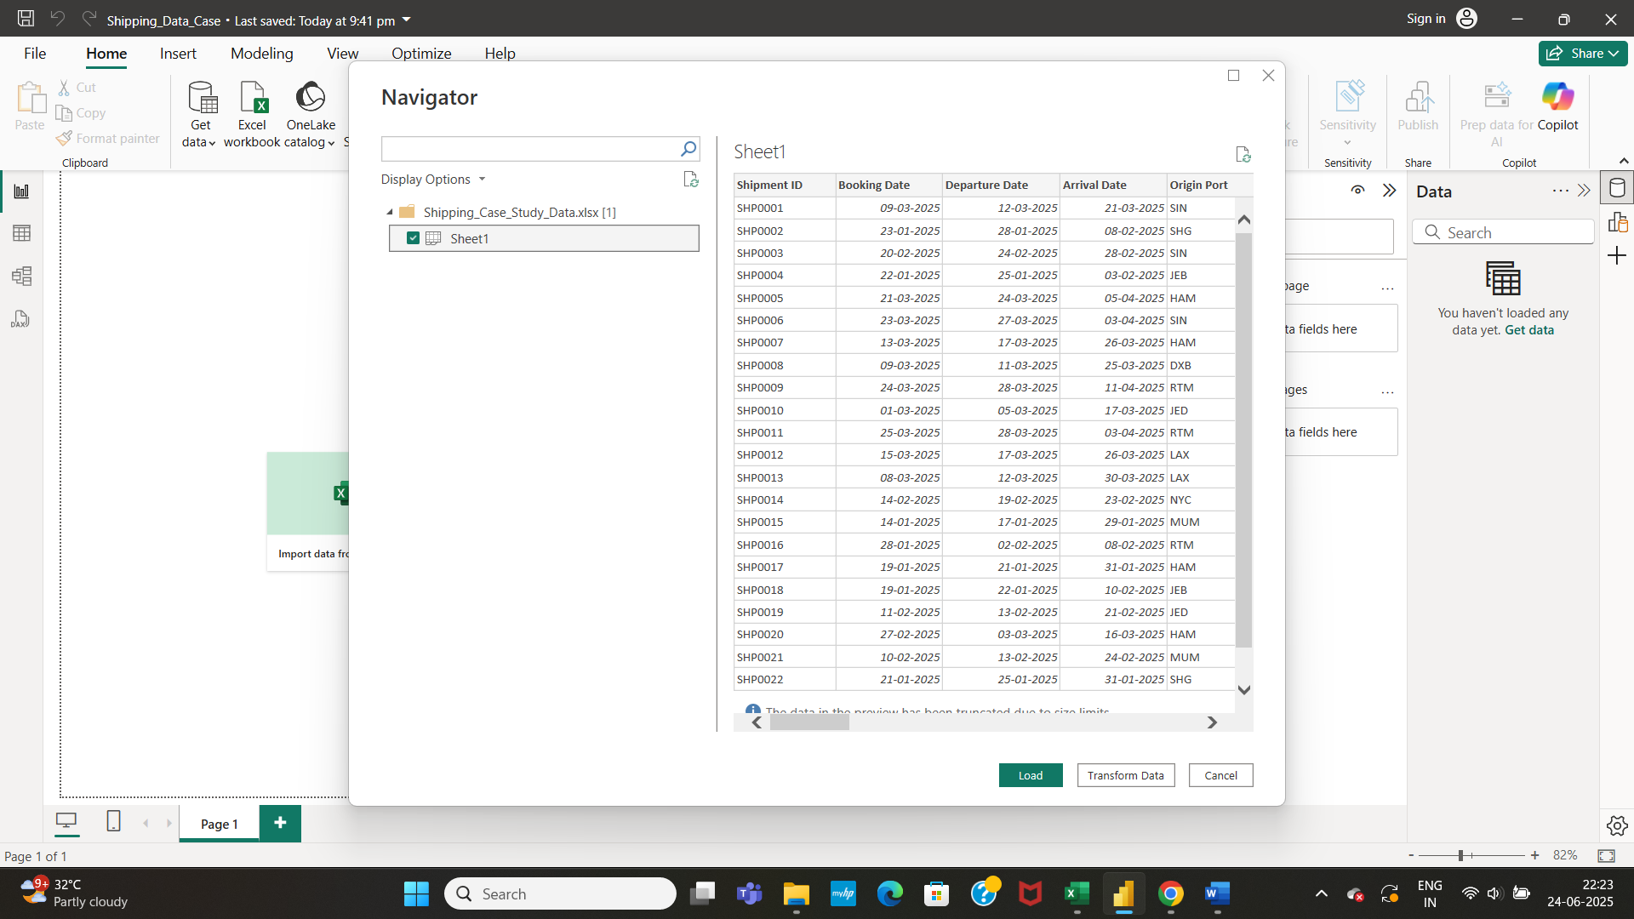

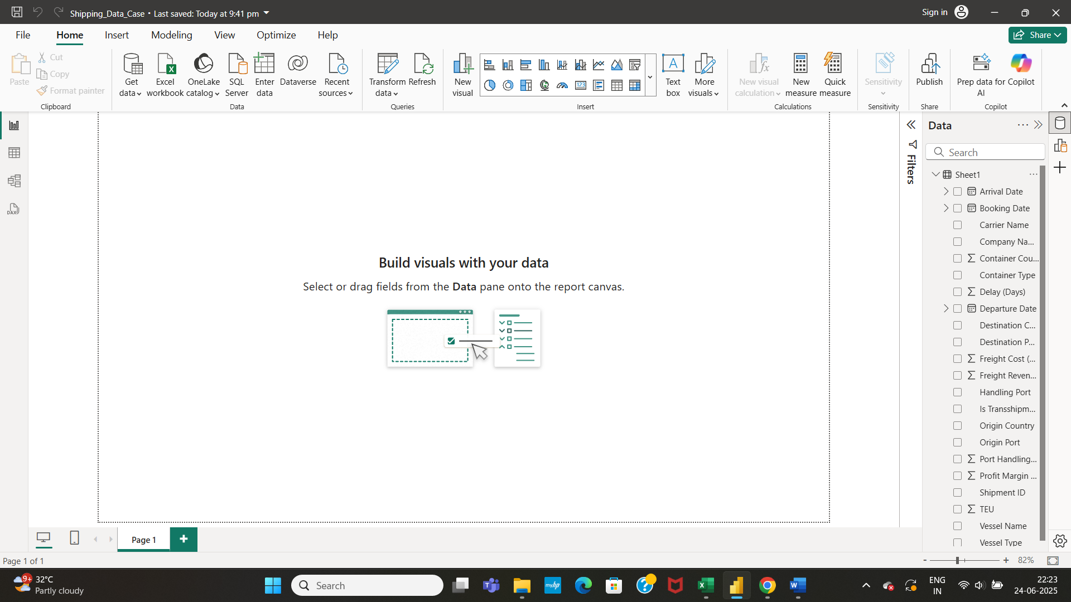

* Rename the table name from Sheet1 to Shipping_Data

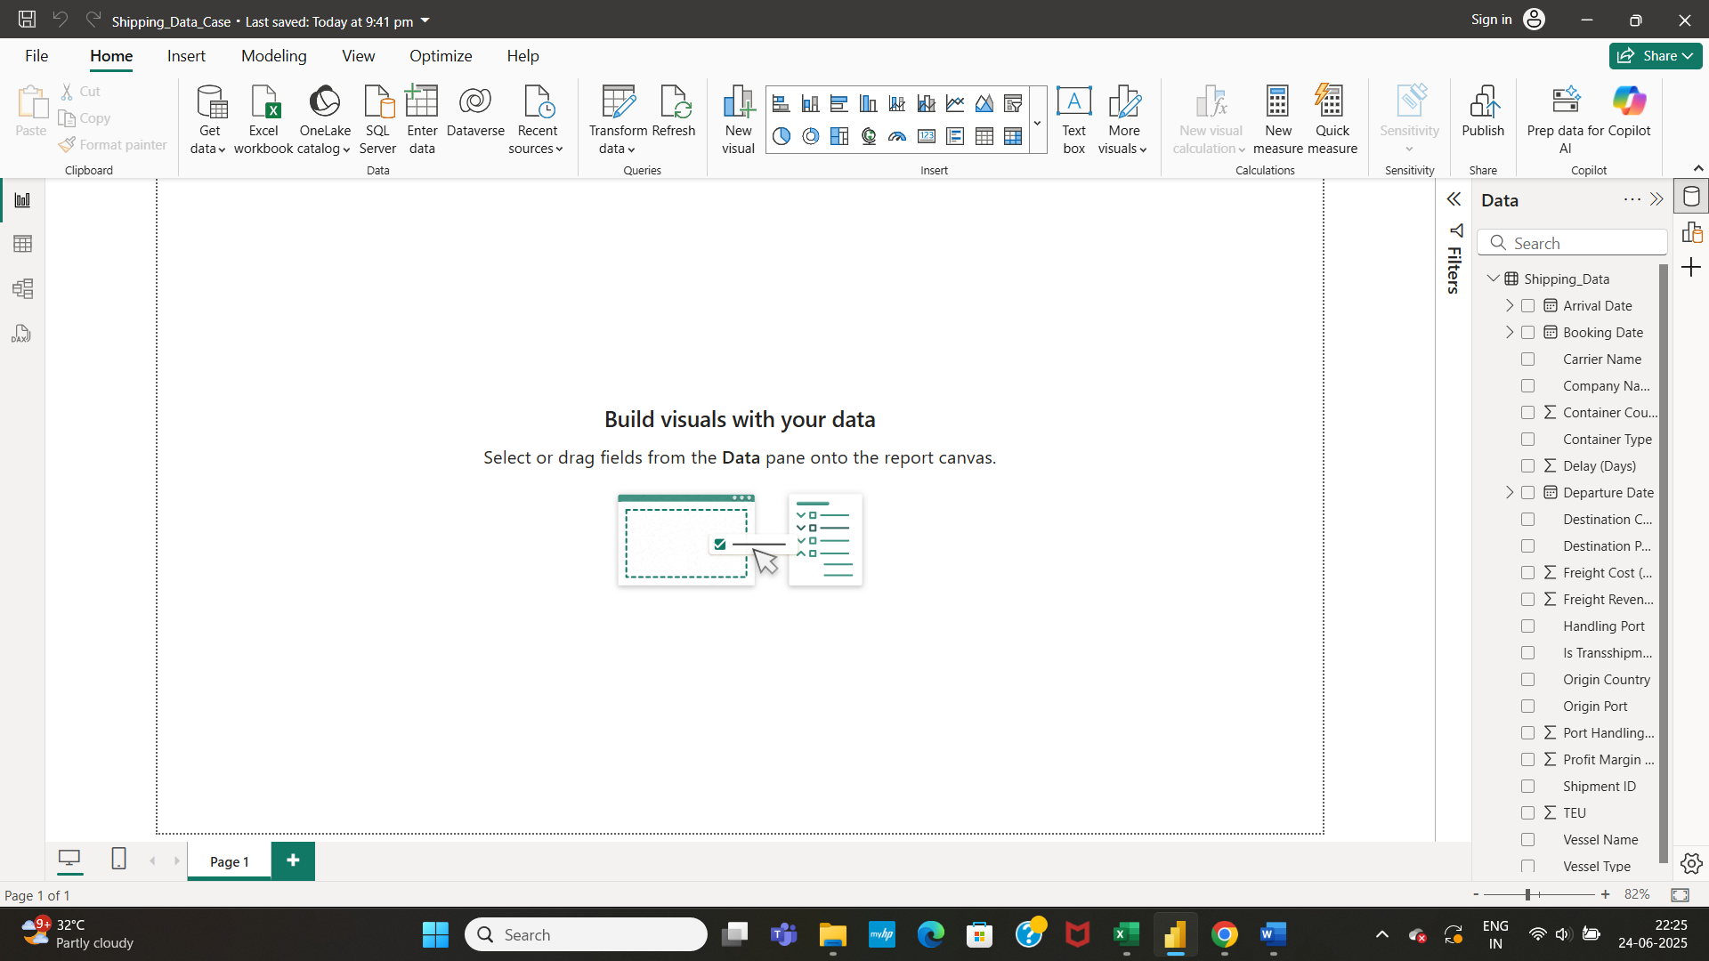

* Click on Transform Data to handle missing values and null values of certain columns present in the data

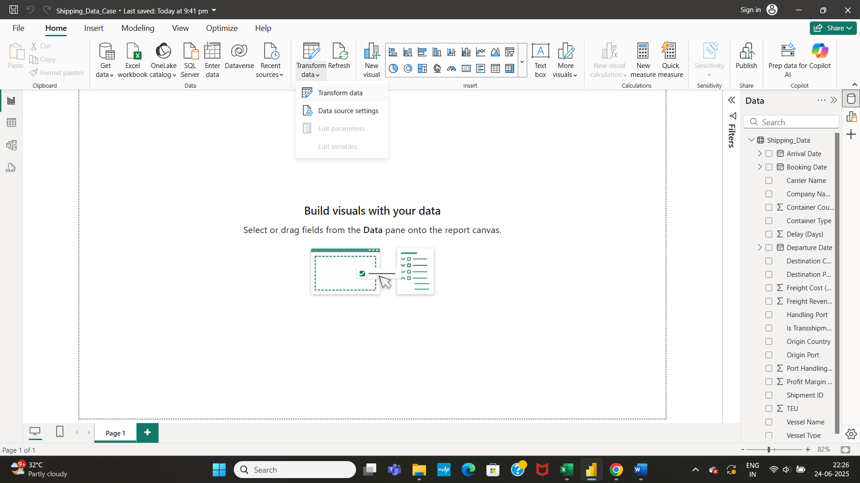

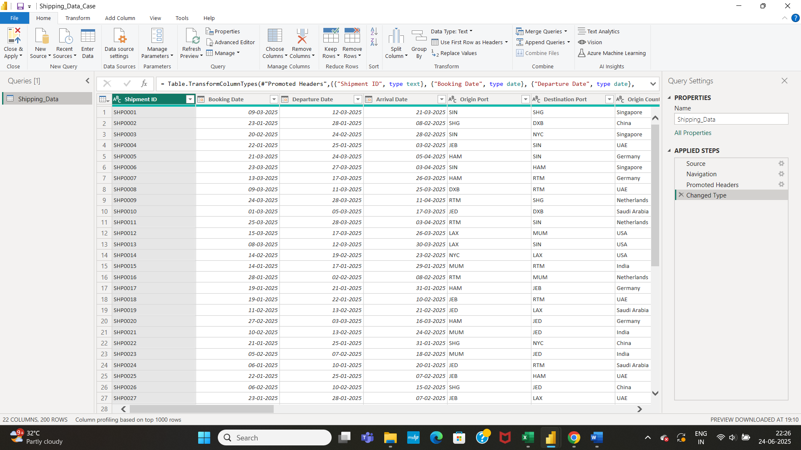

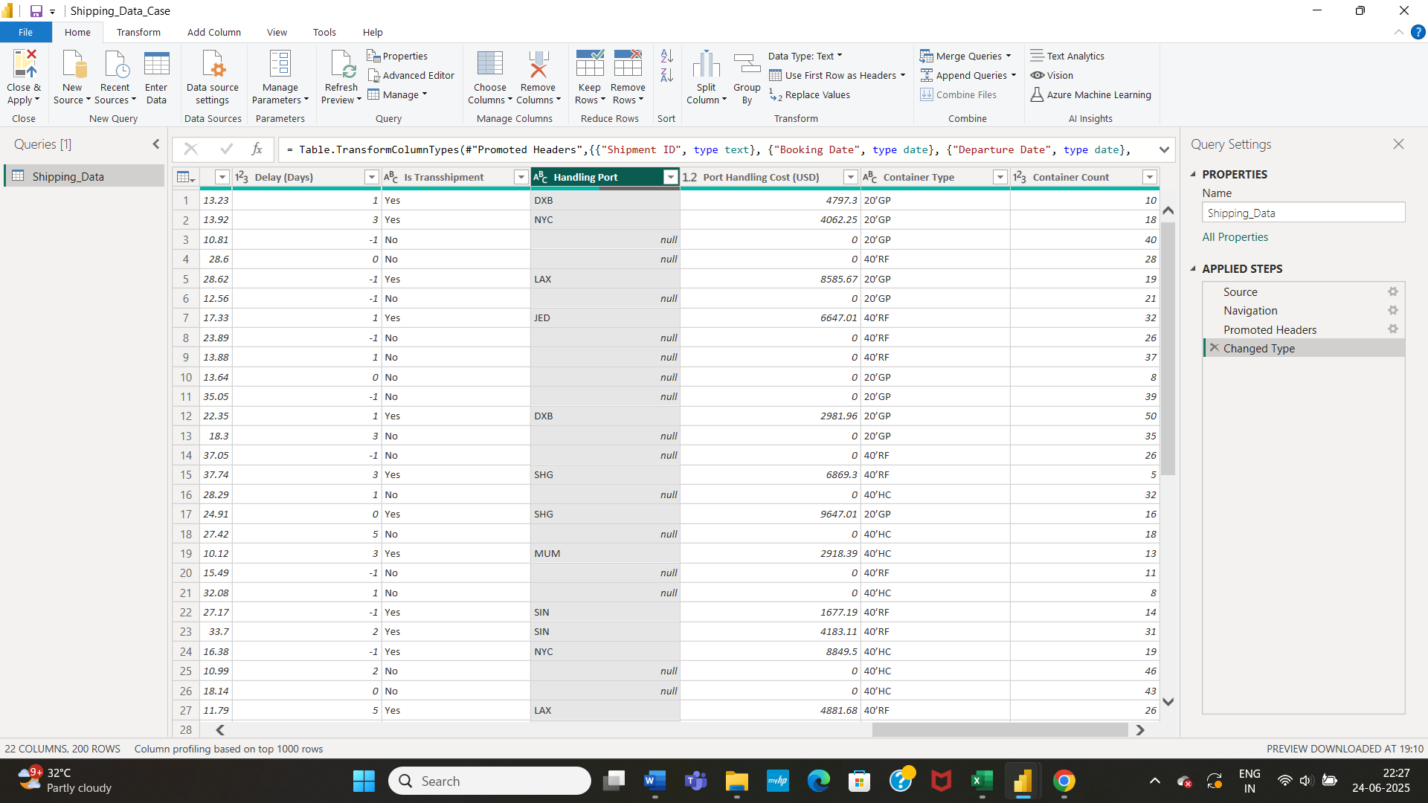

* Calculate the mode of the categorical column **Handling Port** fill in the null values of data with mode of the categorical column.

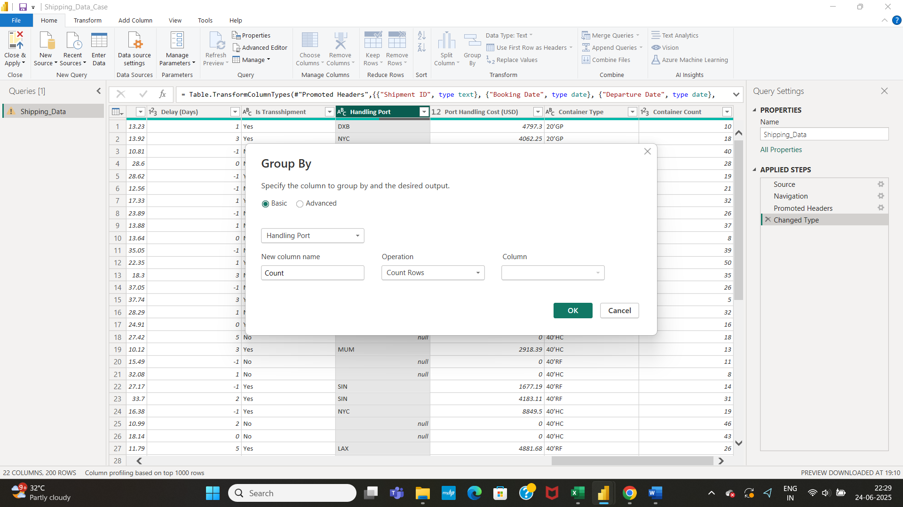

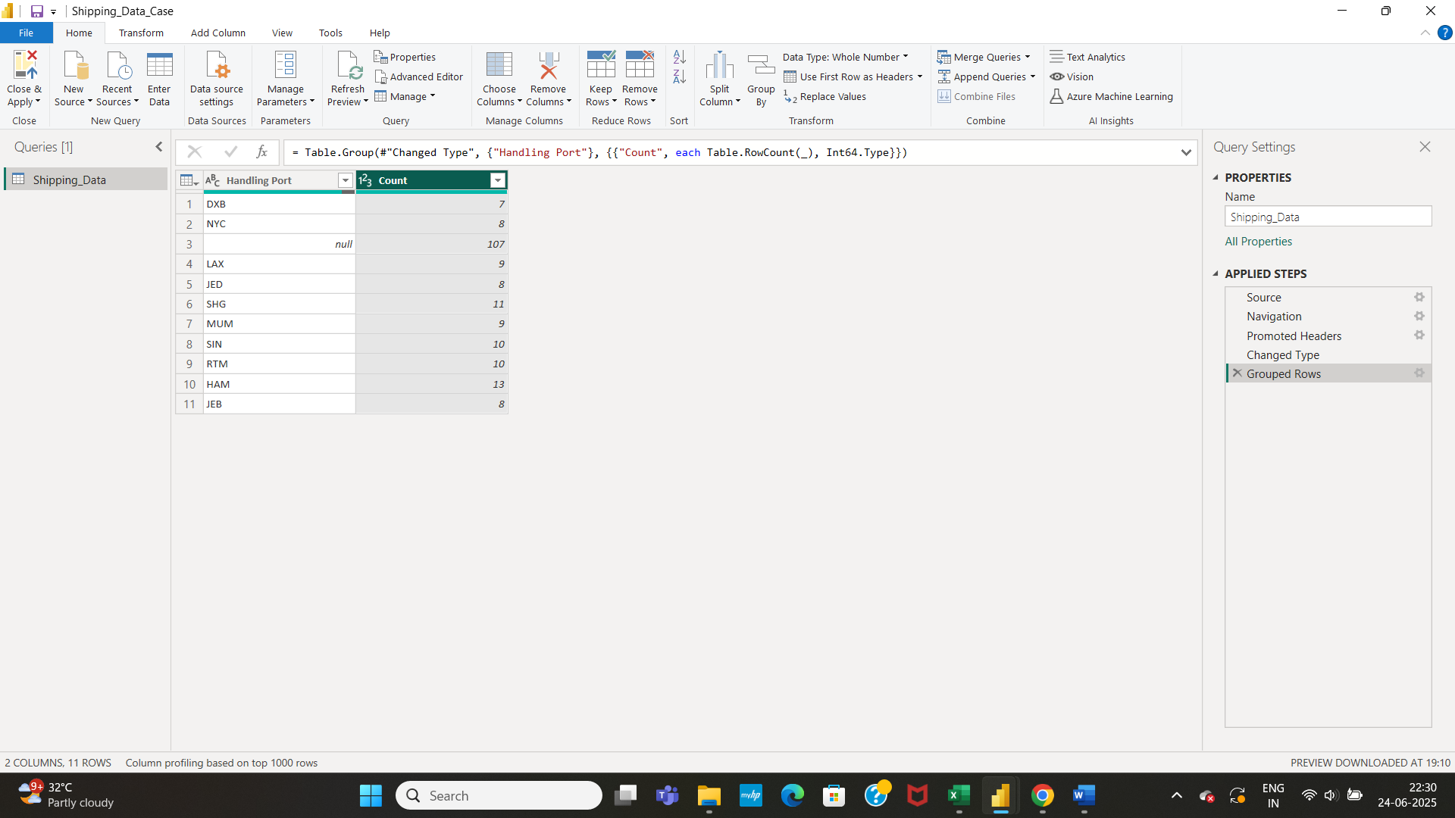

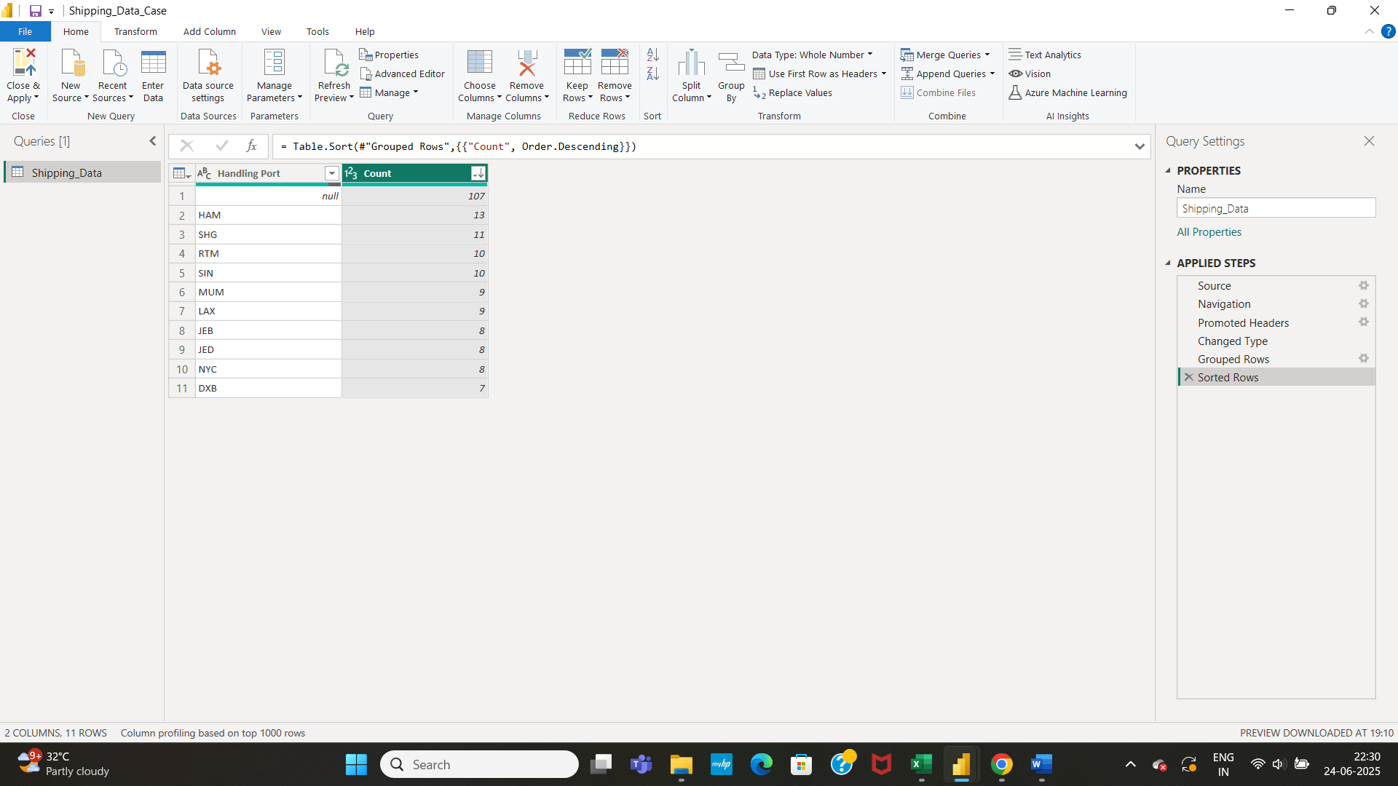

* Click on replace values option to replace the null values with mode of the column.

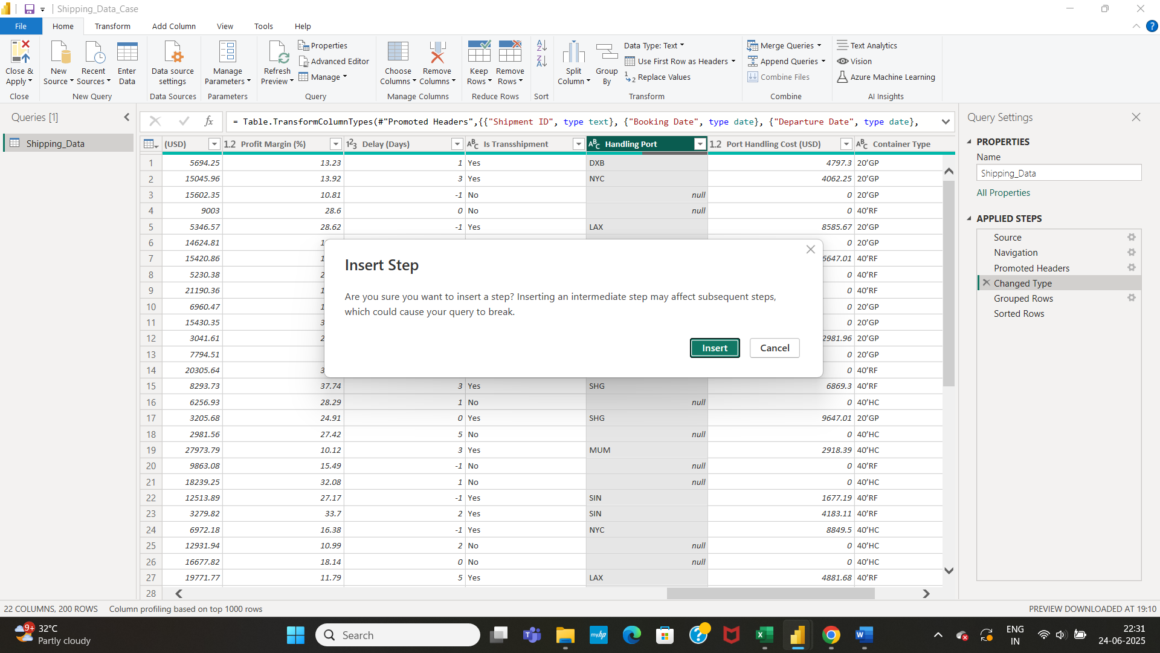

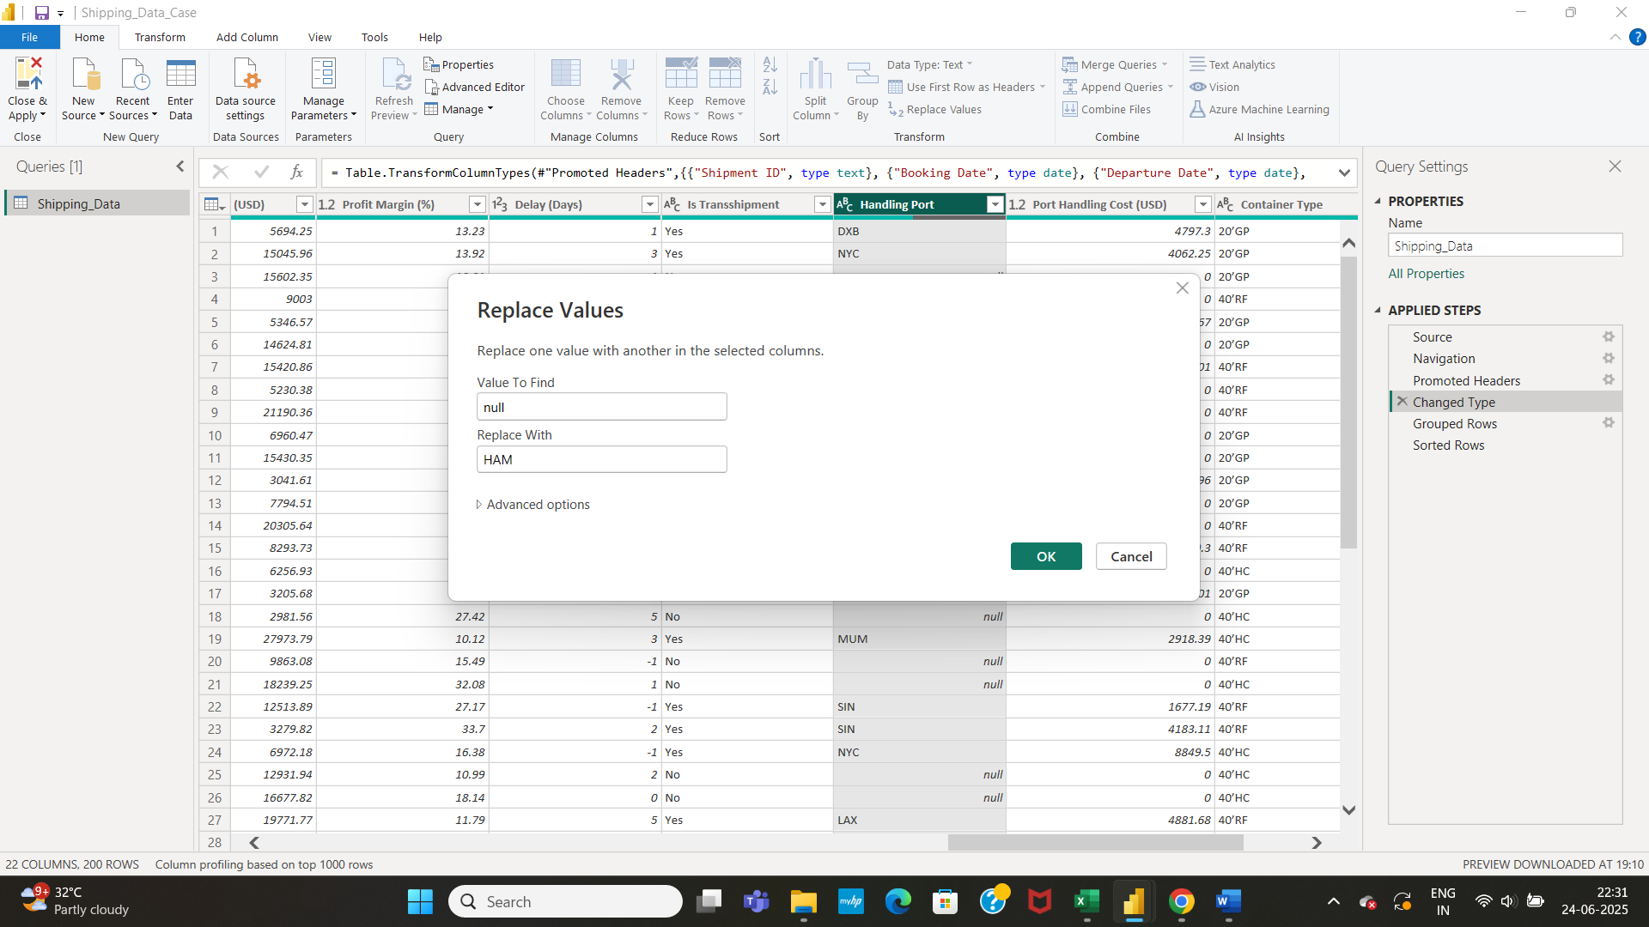

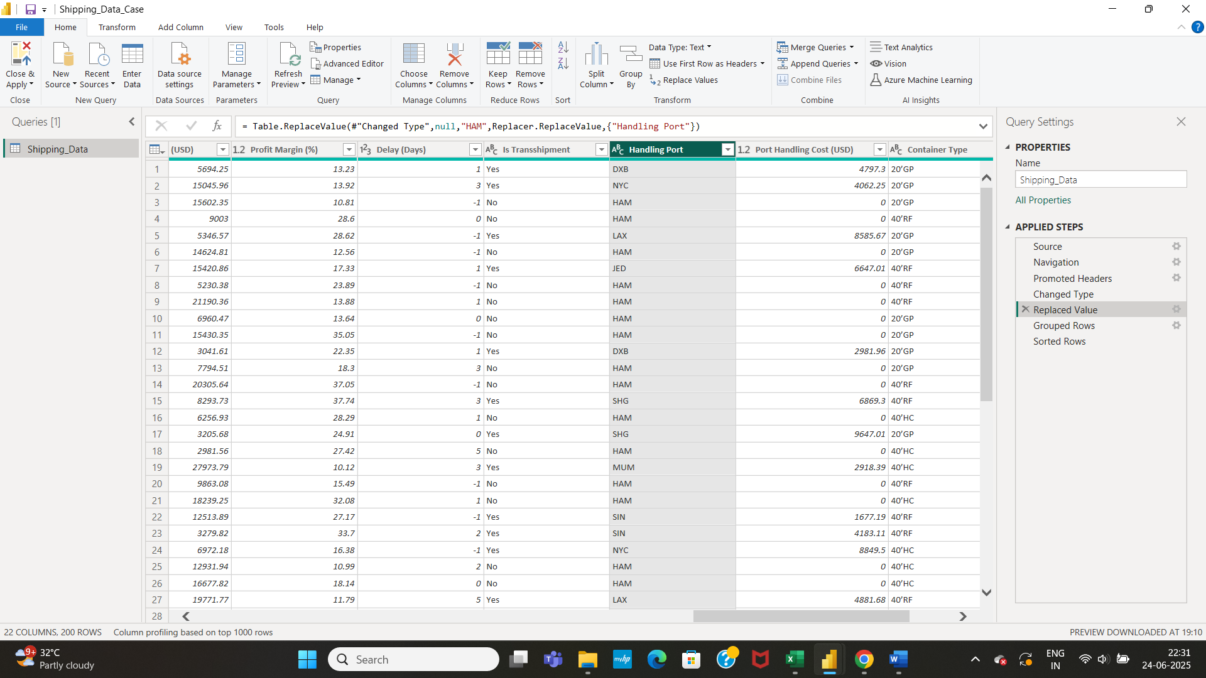

* Fill in the missing values of the numerical column Handling Cost with the average of the Handling cost data. Click on Statistics option and under Statistics, click Average.

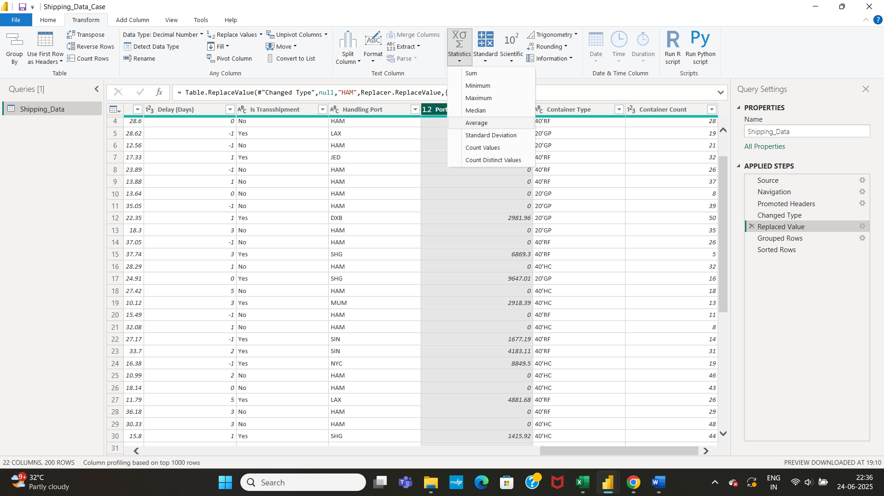

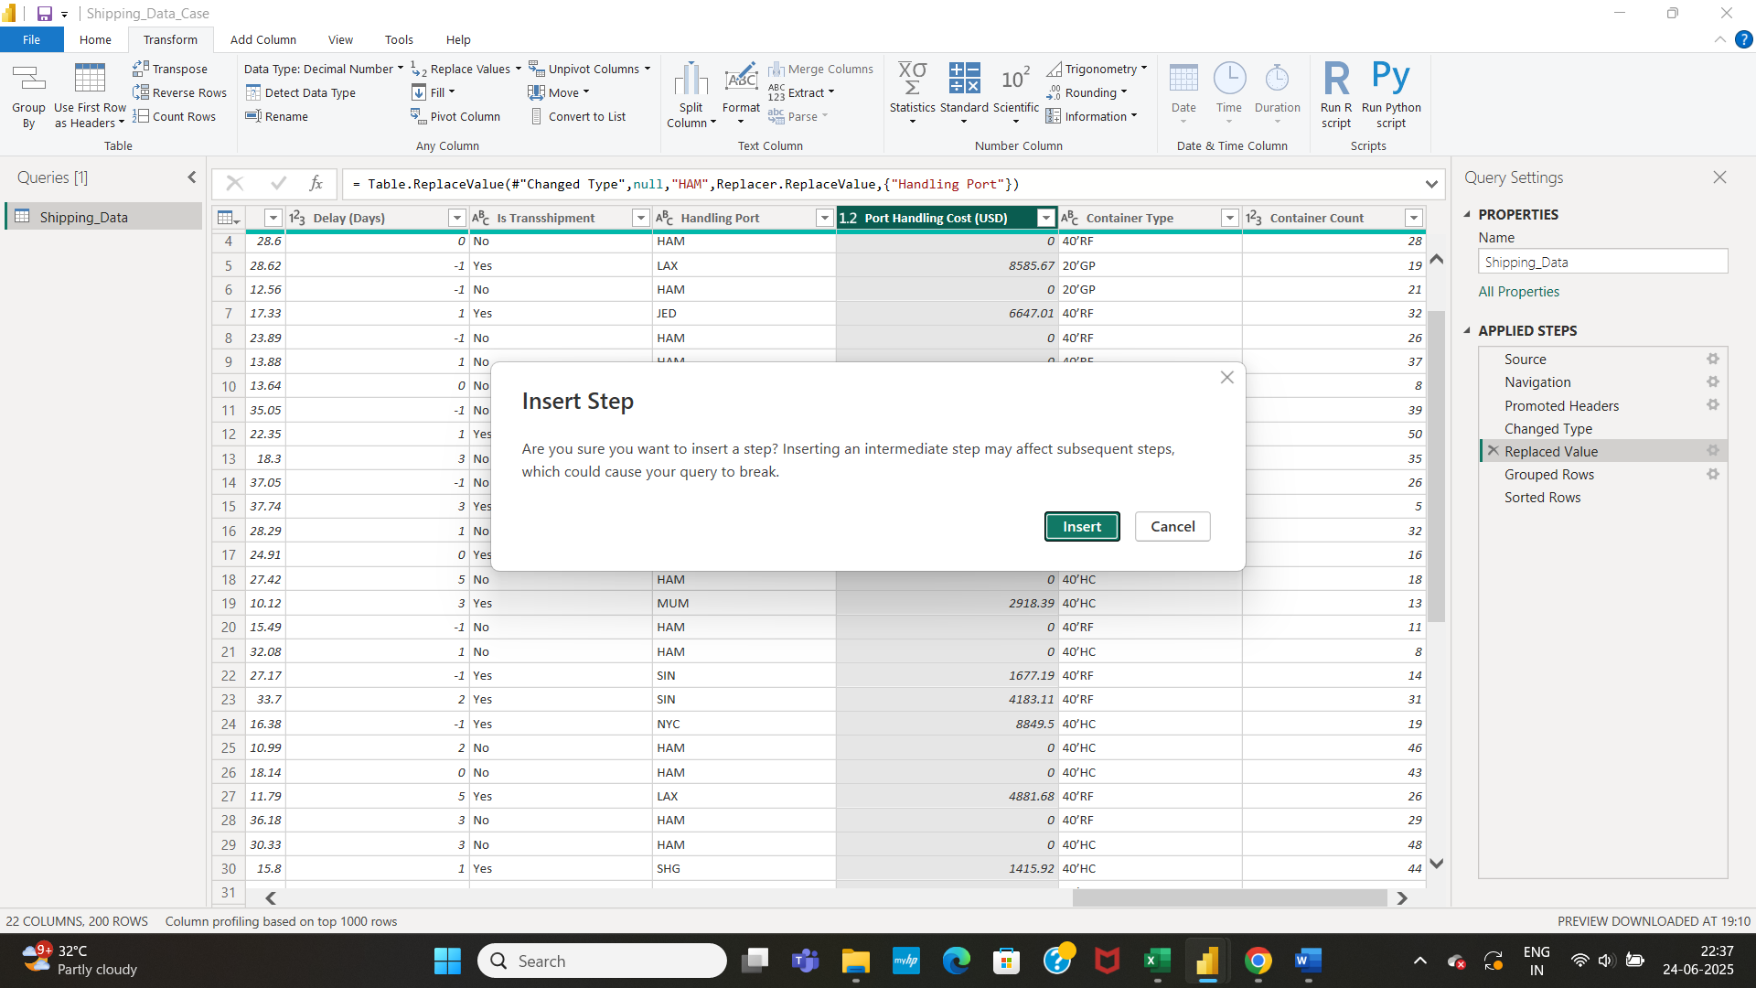

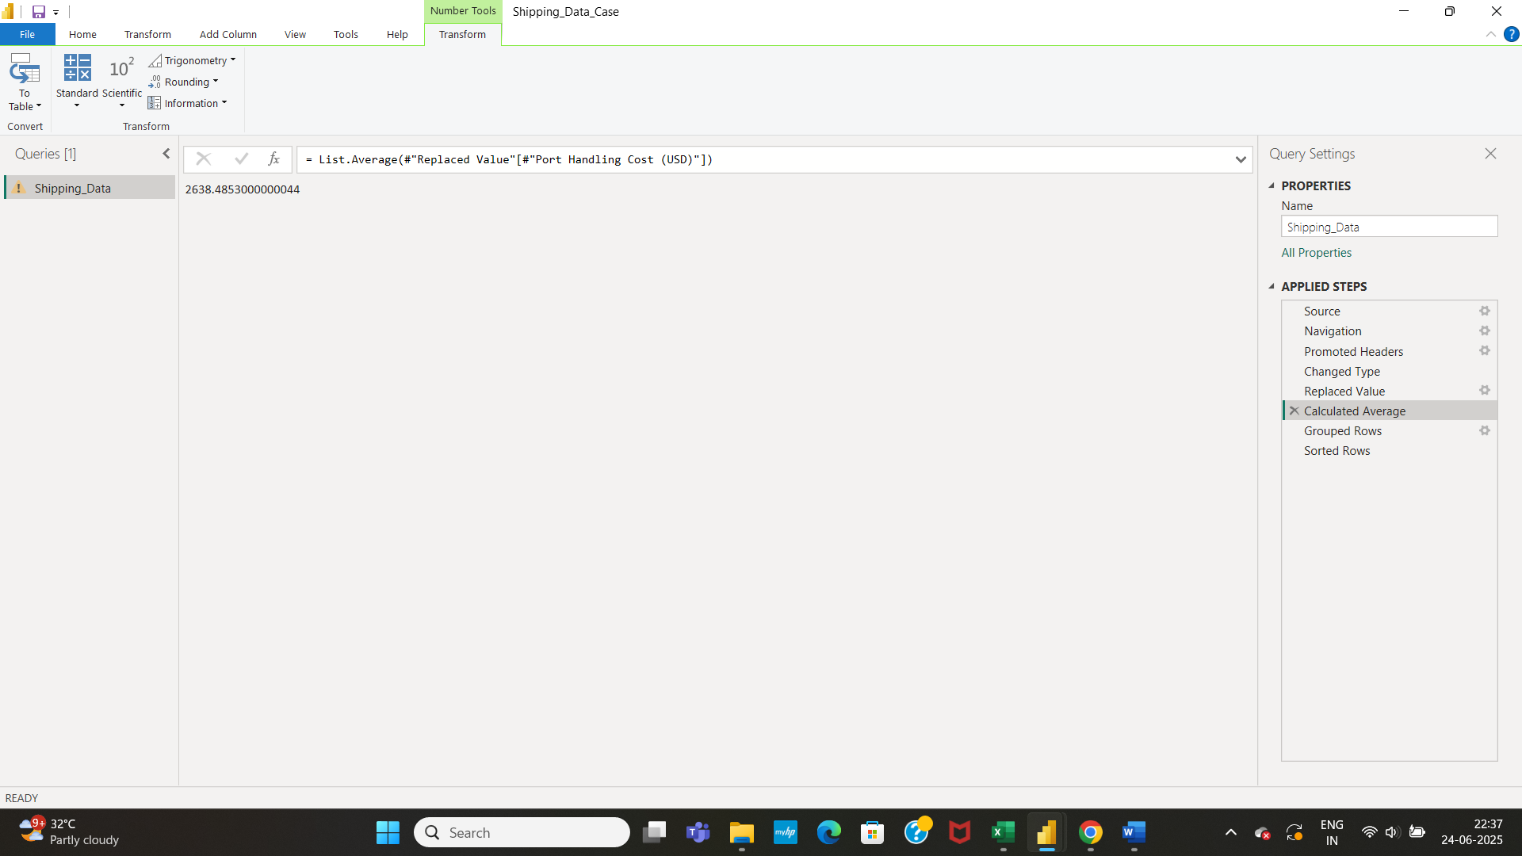

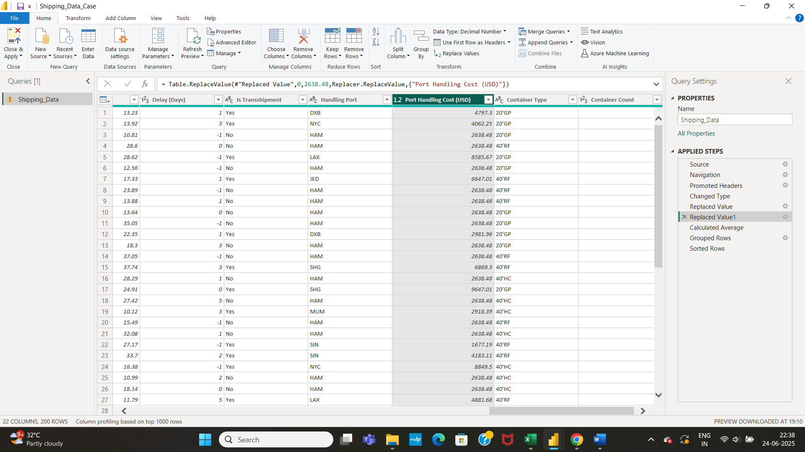

* Then click on Close and Apply. Get back to Report View page.

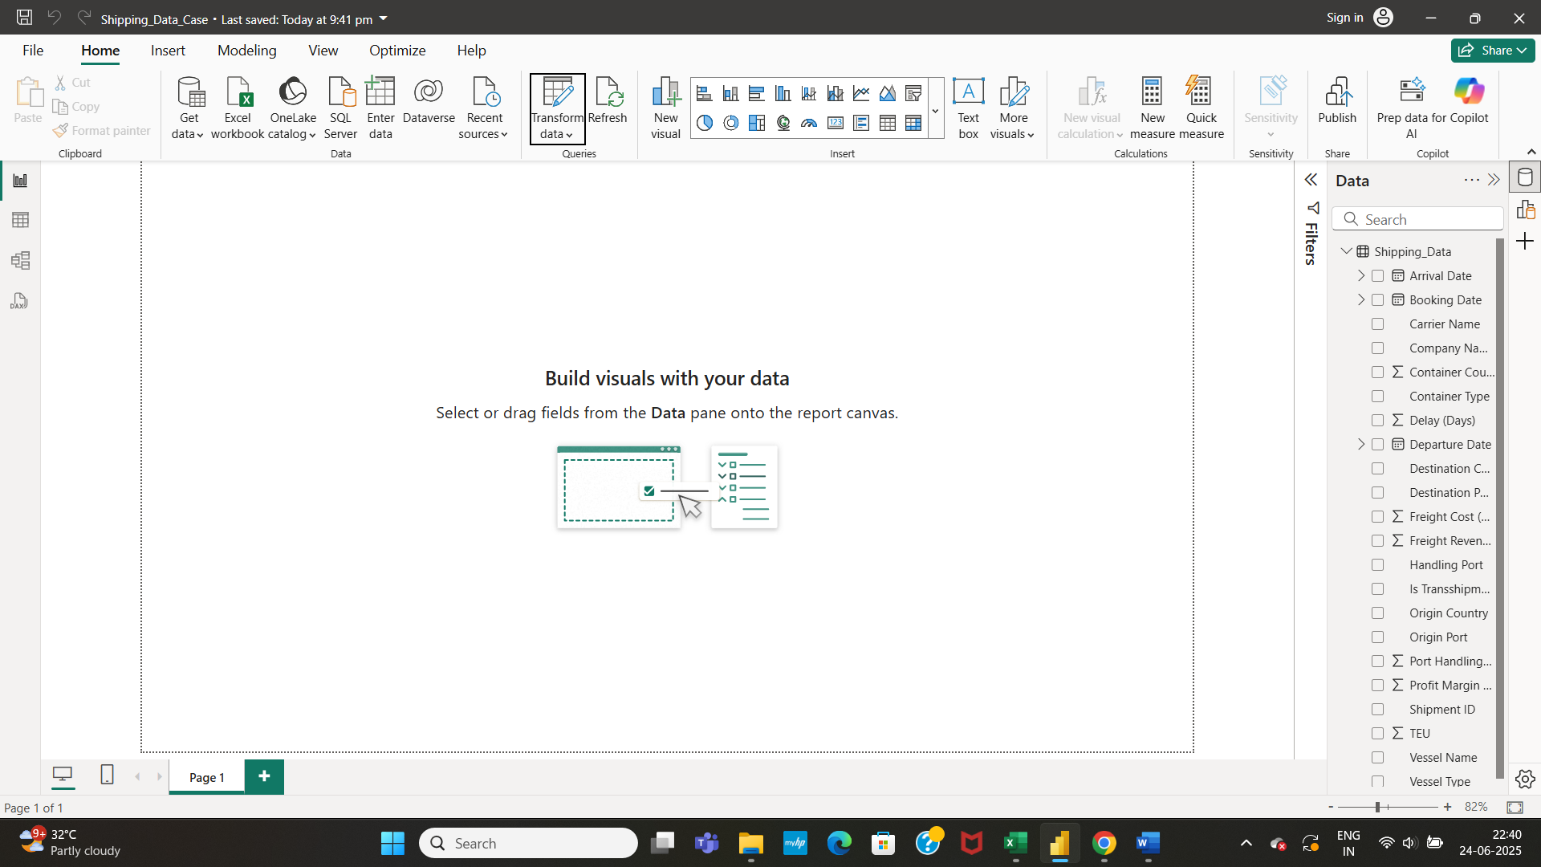

* We have to insert new columns like (DateID, PortID, etc) for the different columns present so that during data modelling, these columns can be grouped under one table.
* Under Modeling tab, click on new column to create the required columns.

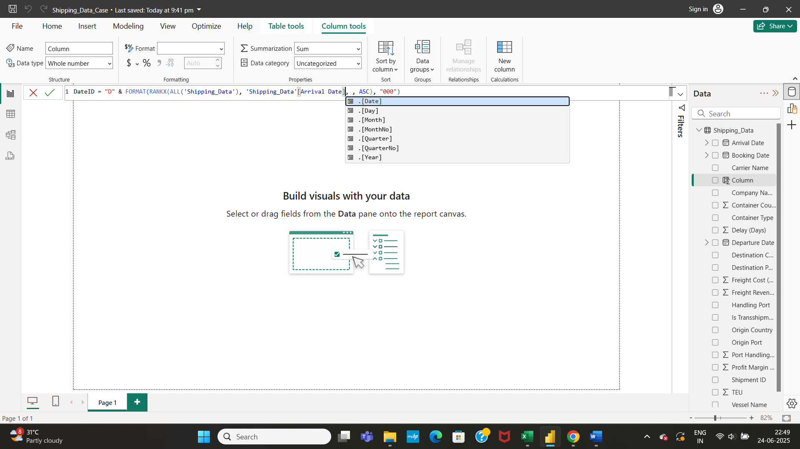

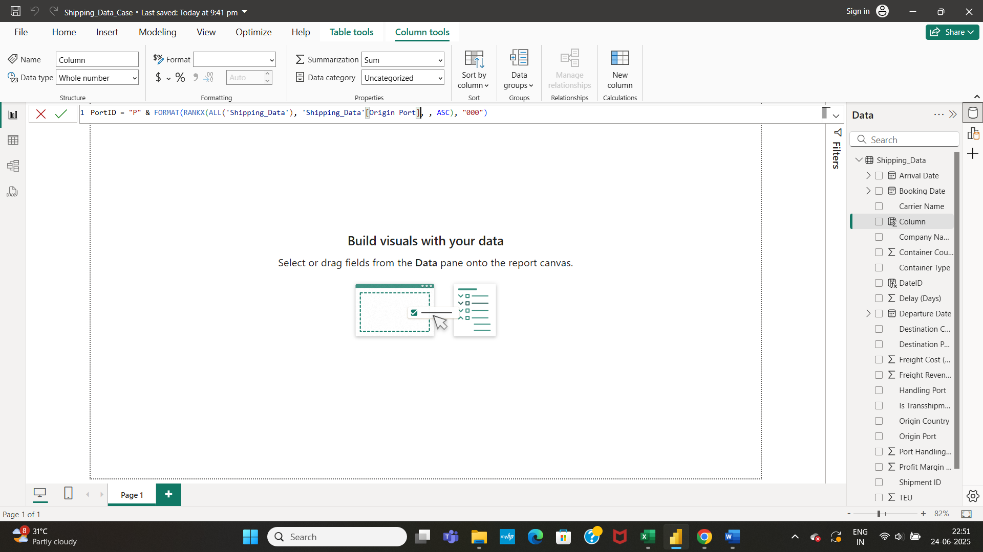

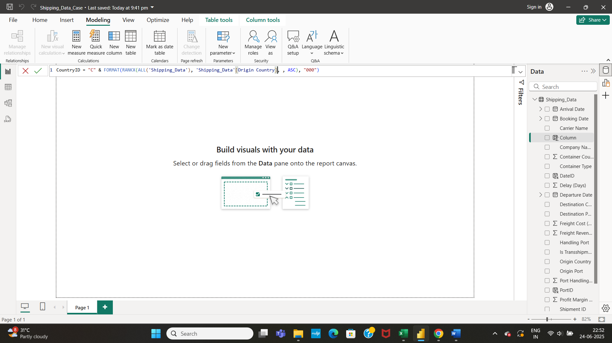

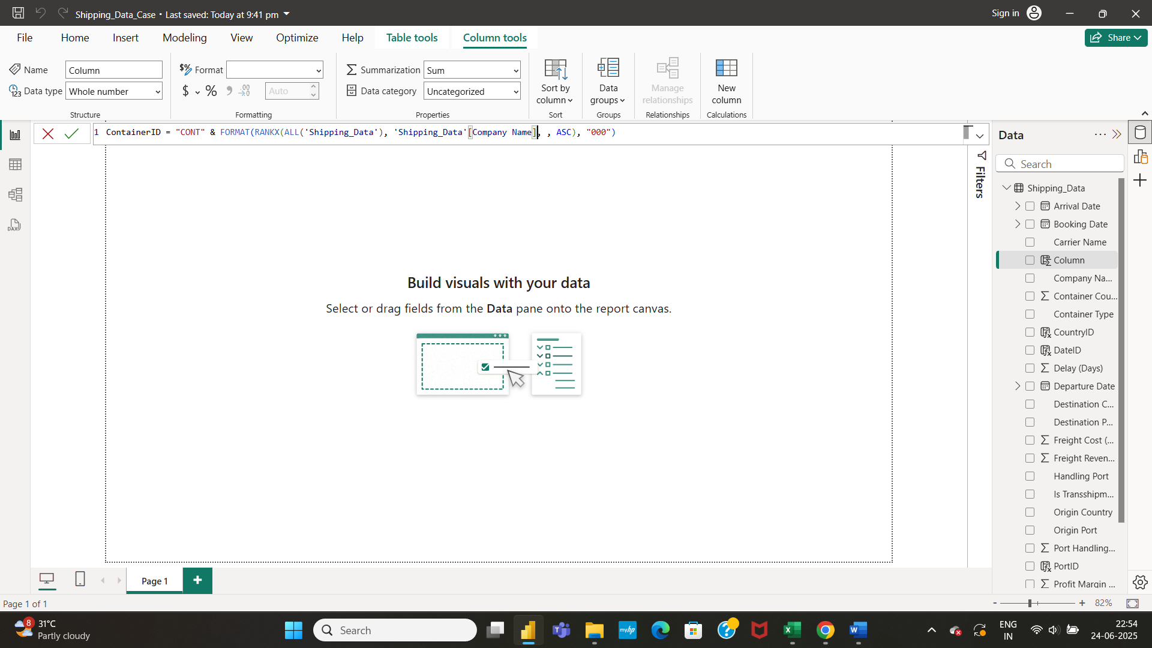

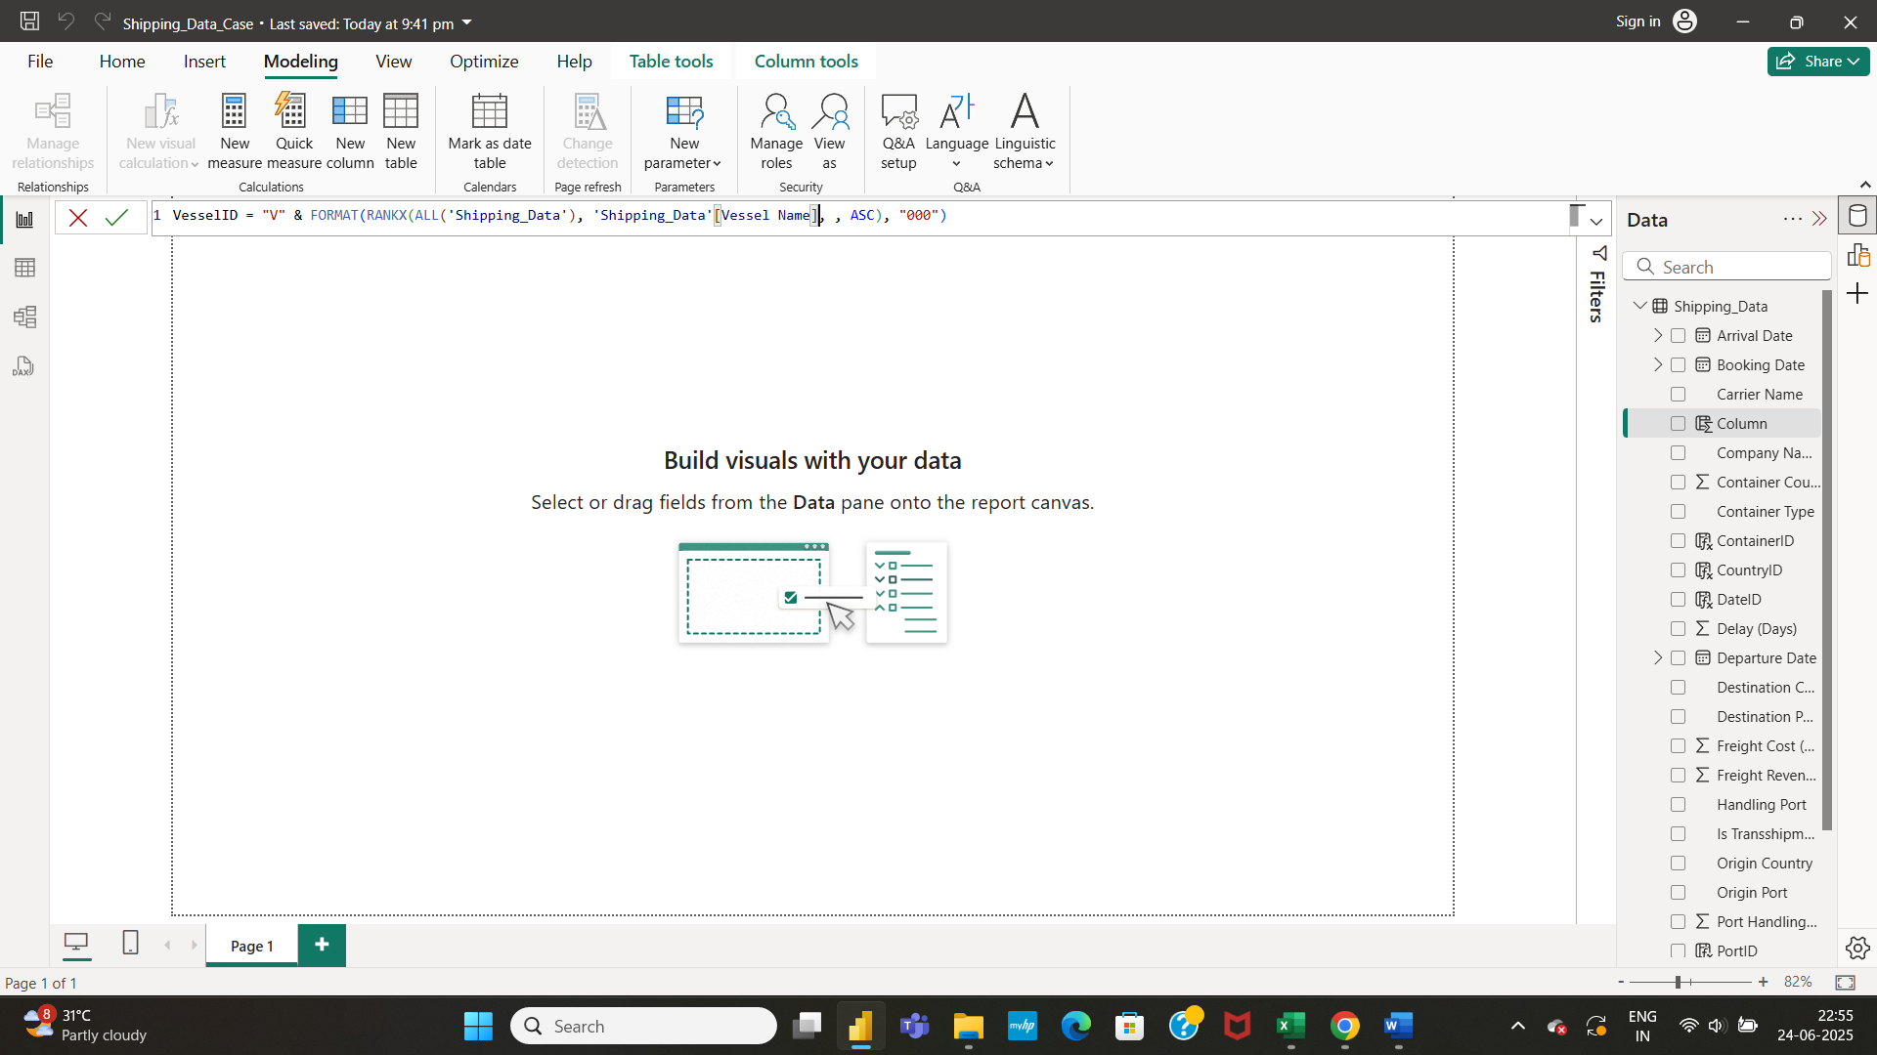

* After creating new columns in the Shipping_Data table, data modelling has to be done.

**DATA MODELING:**

* Creation of Dimension tables is very important to build a star shaped schema.

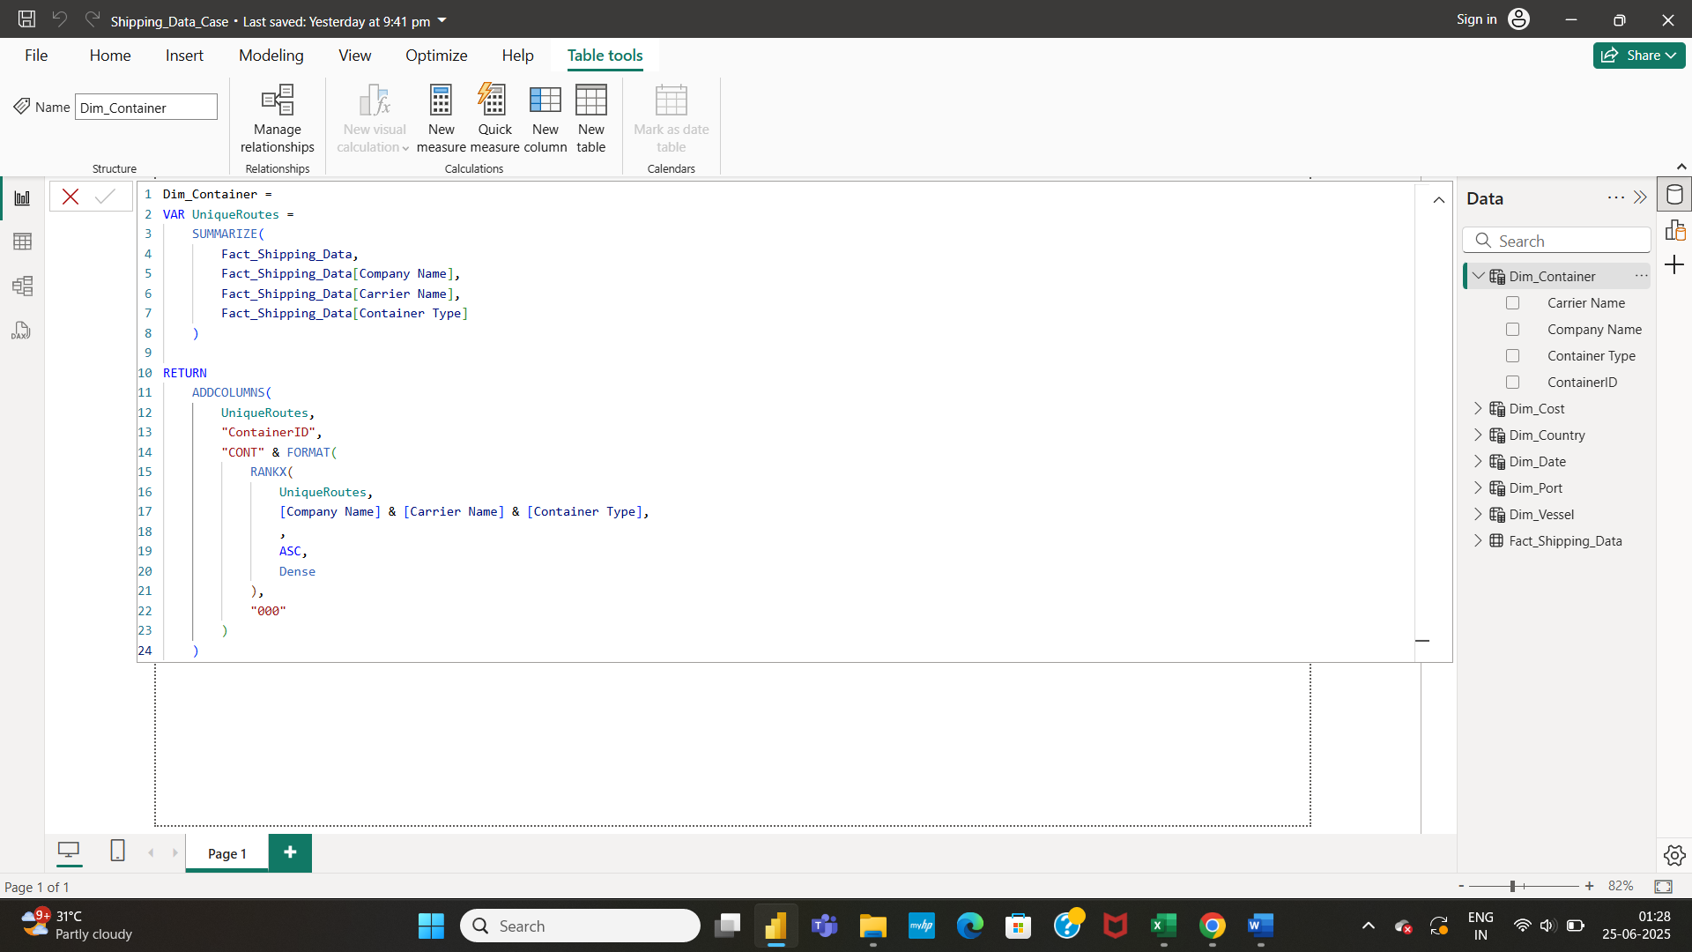

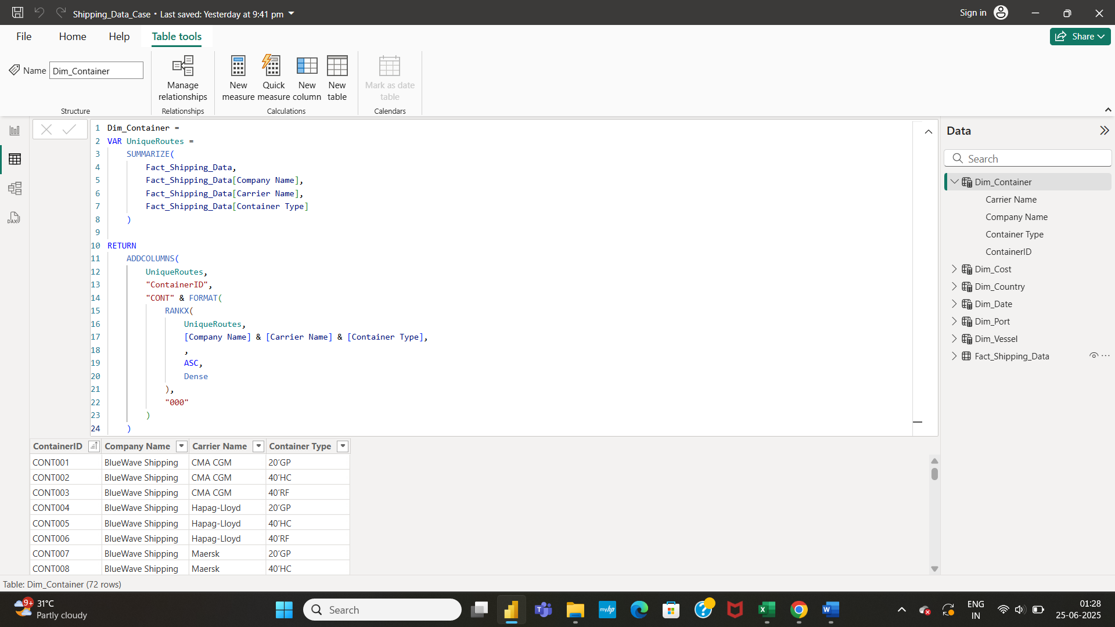

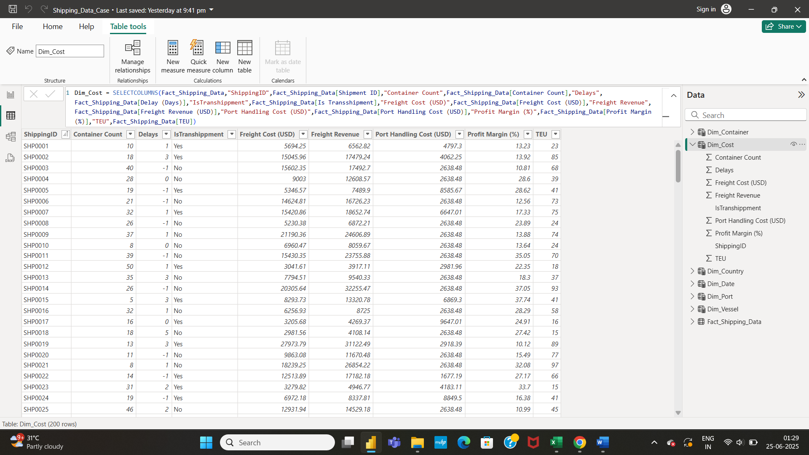

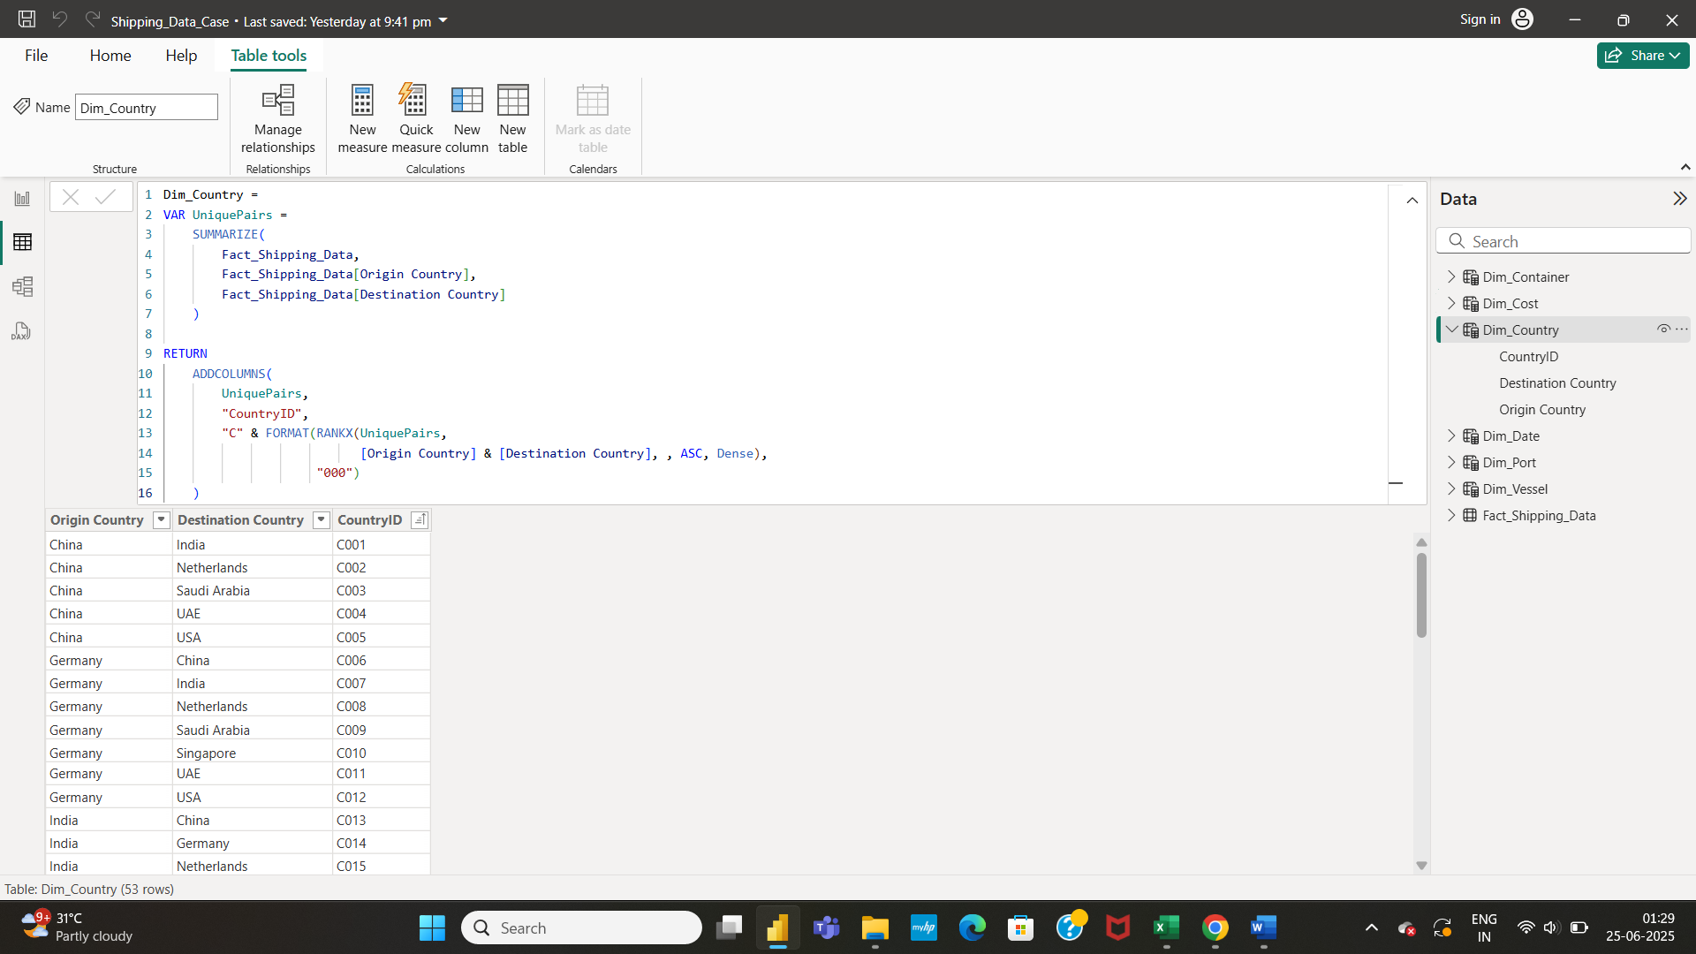

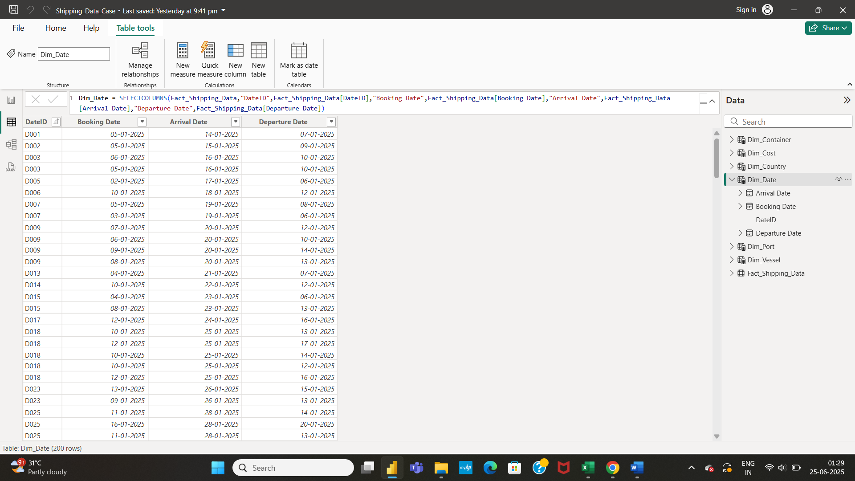

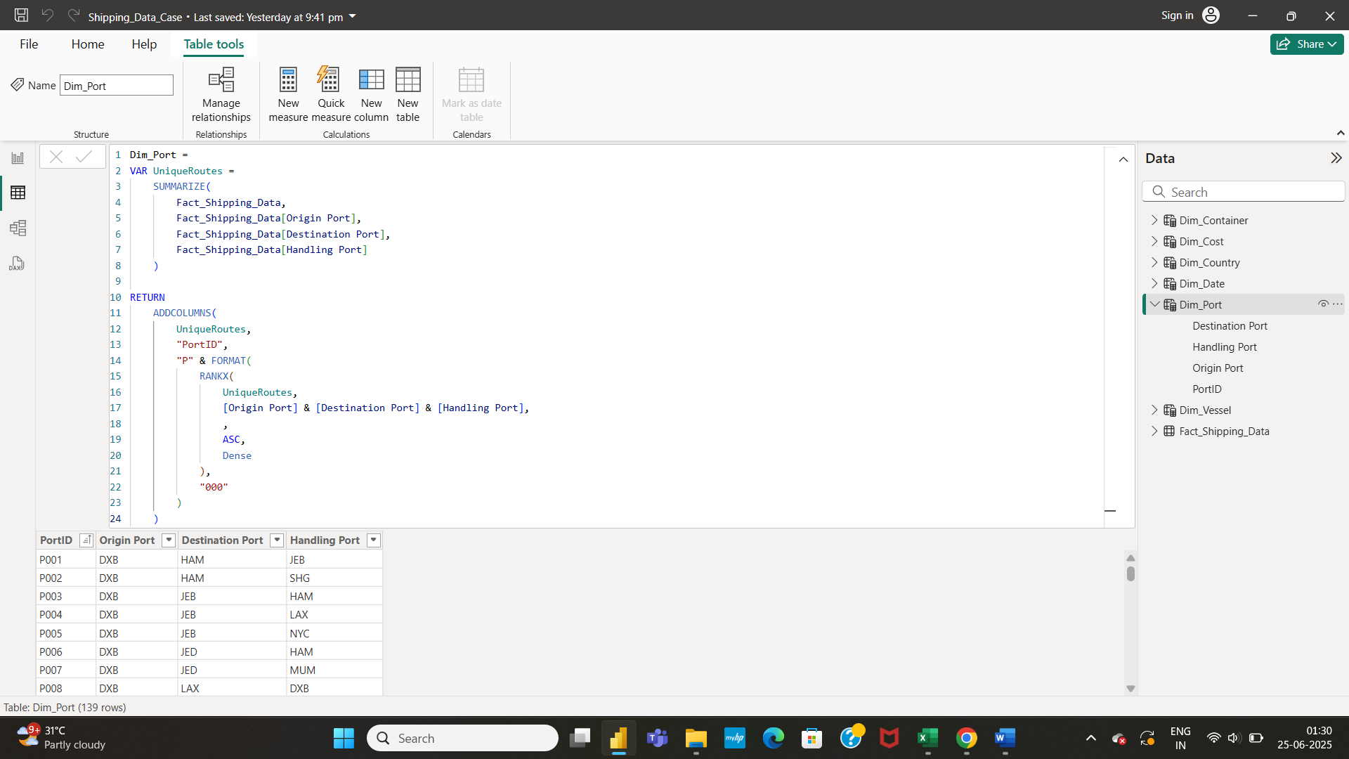

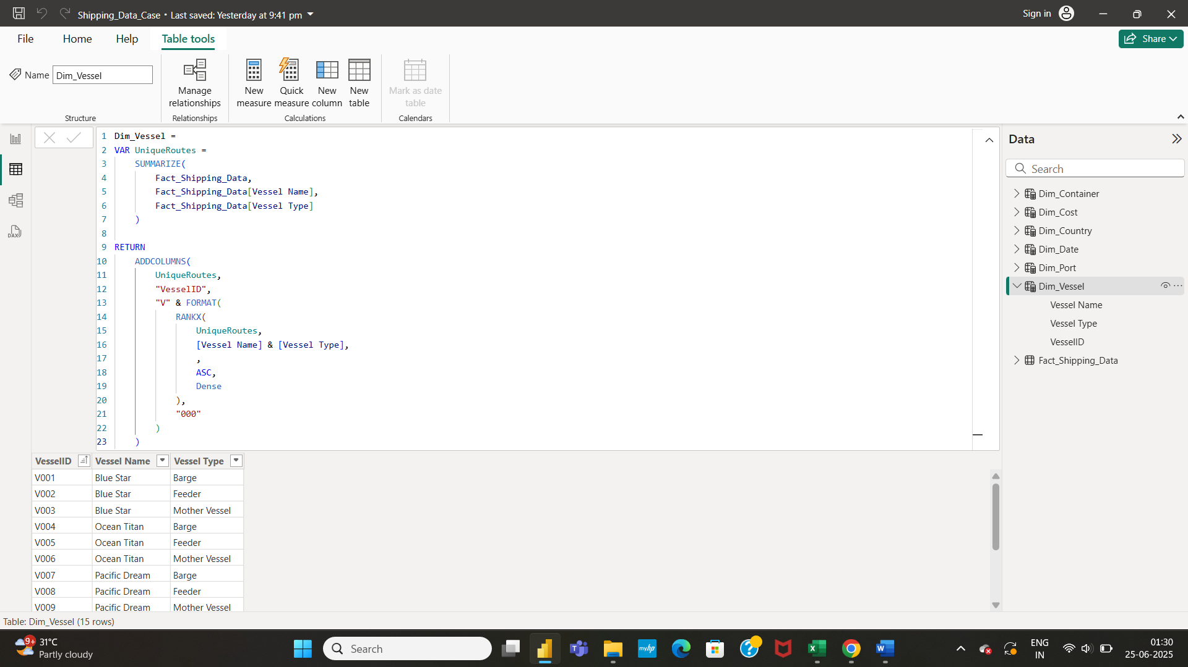

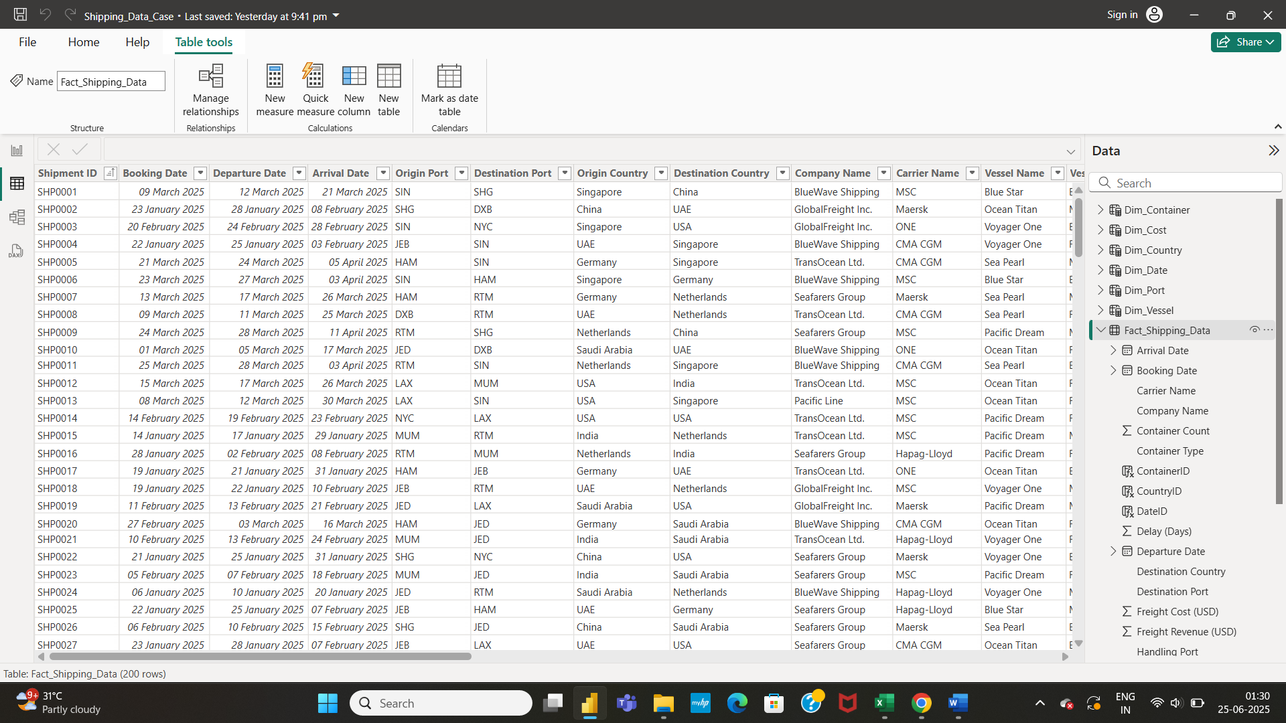

* In the model view, we have to create relationships between fact table and the dimension table. The fact table is the Shipping Data and the dimension tables are Dim_Date, Dim_Port, Dim_Container, Dim_Country, Dim_Vessel, Dim_Cost.

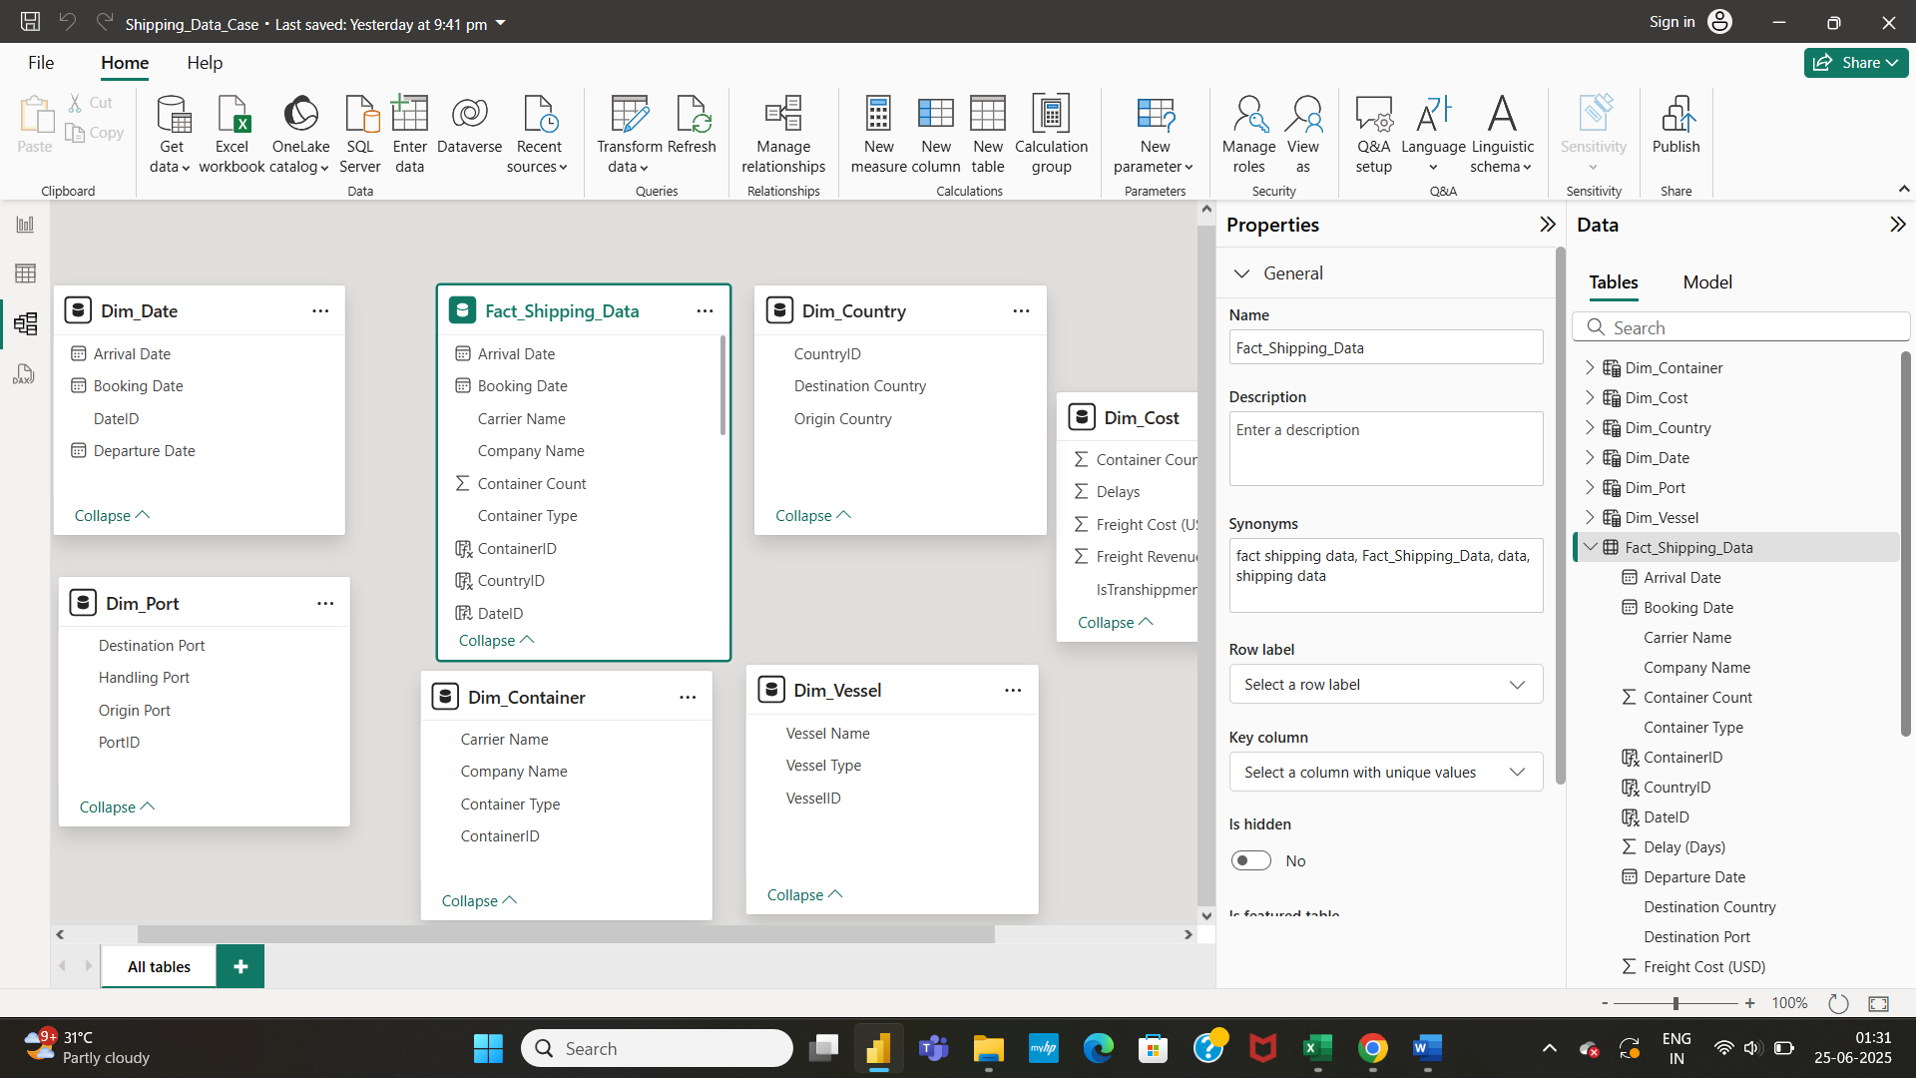

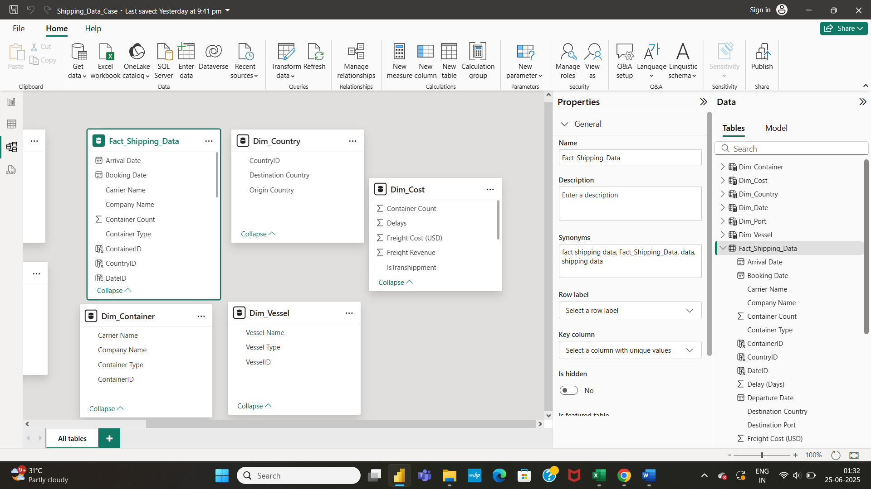

* We shall create relationships between dimension table and fact table present.

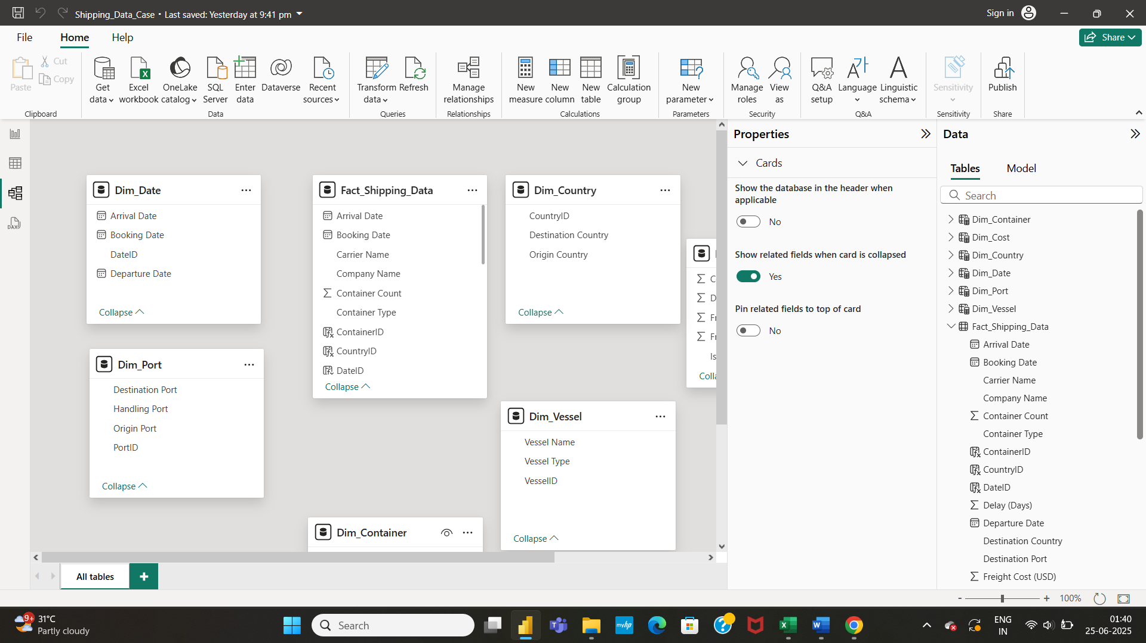

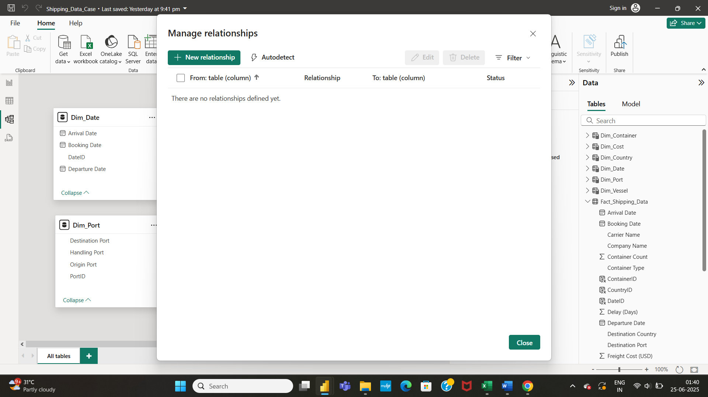

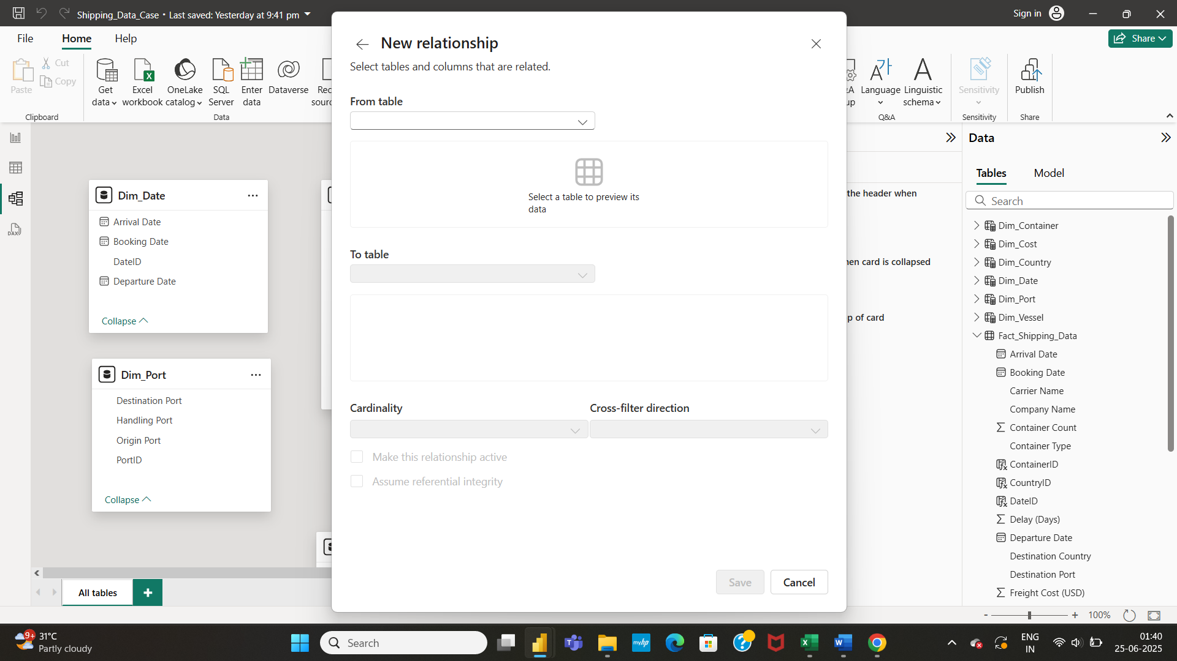

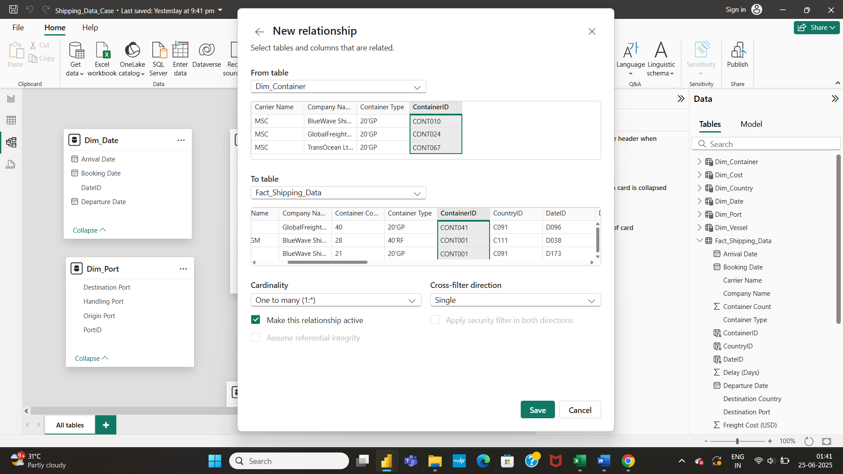

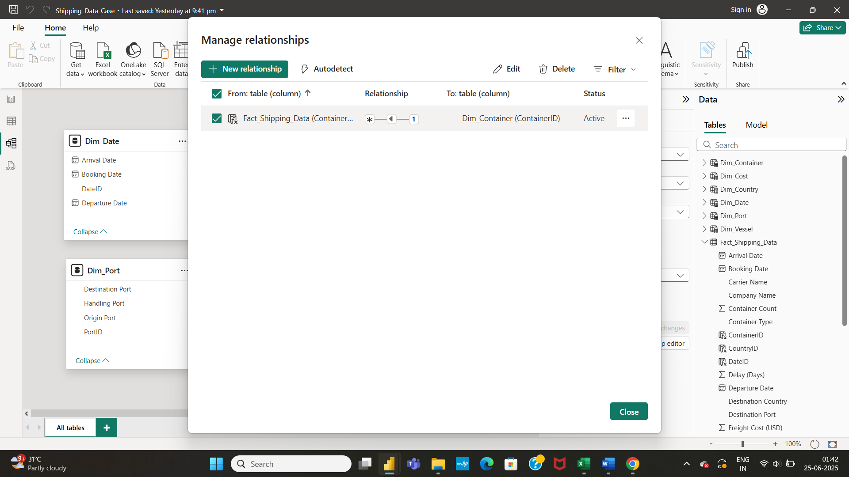

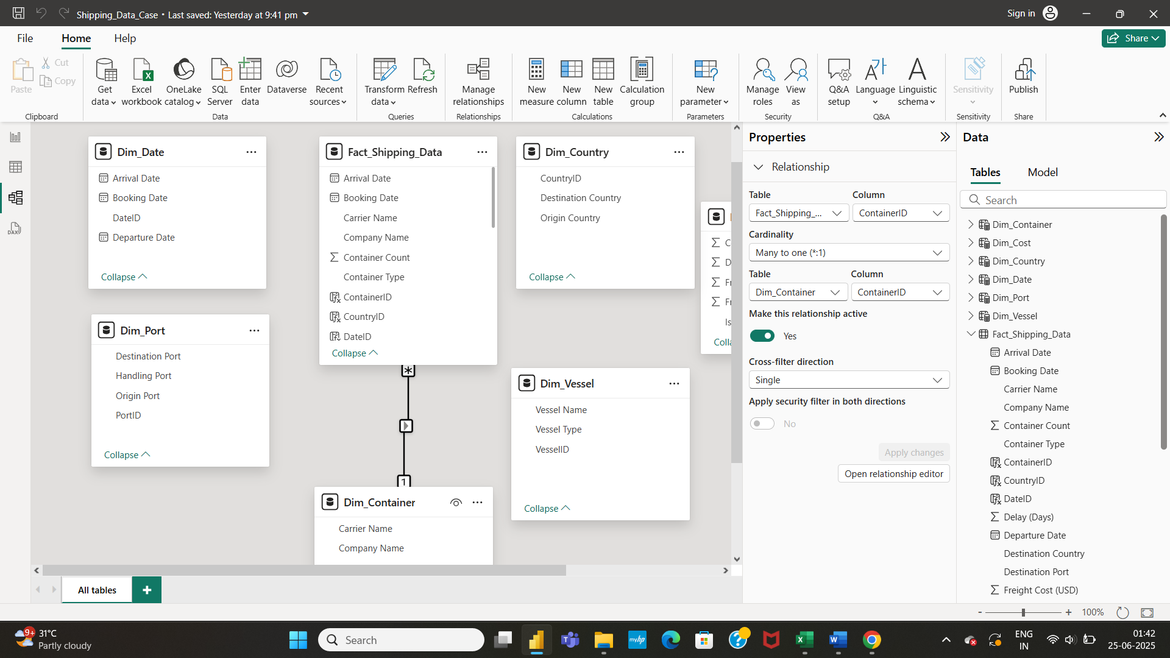

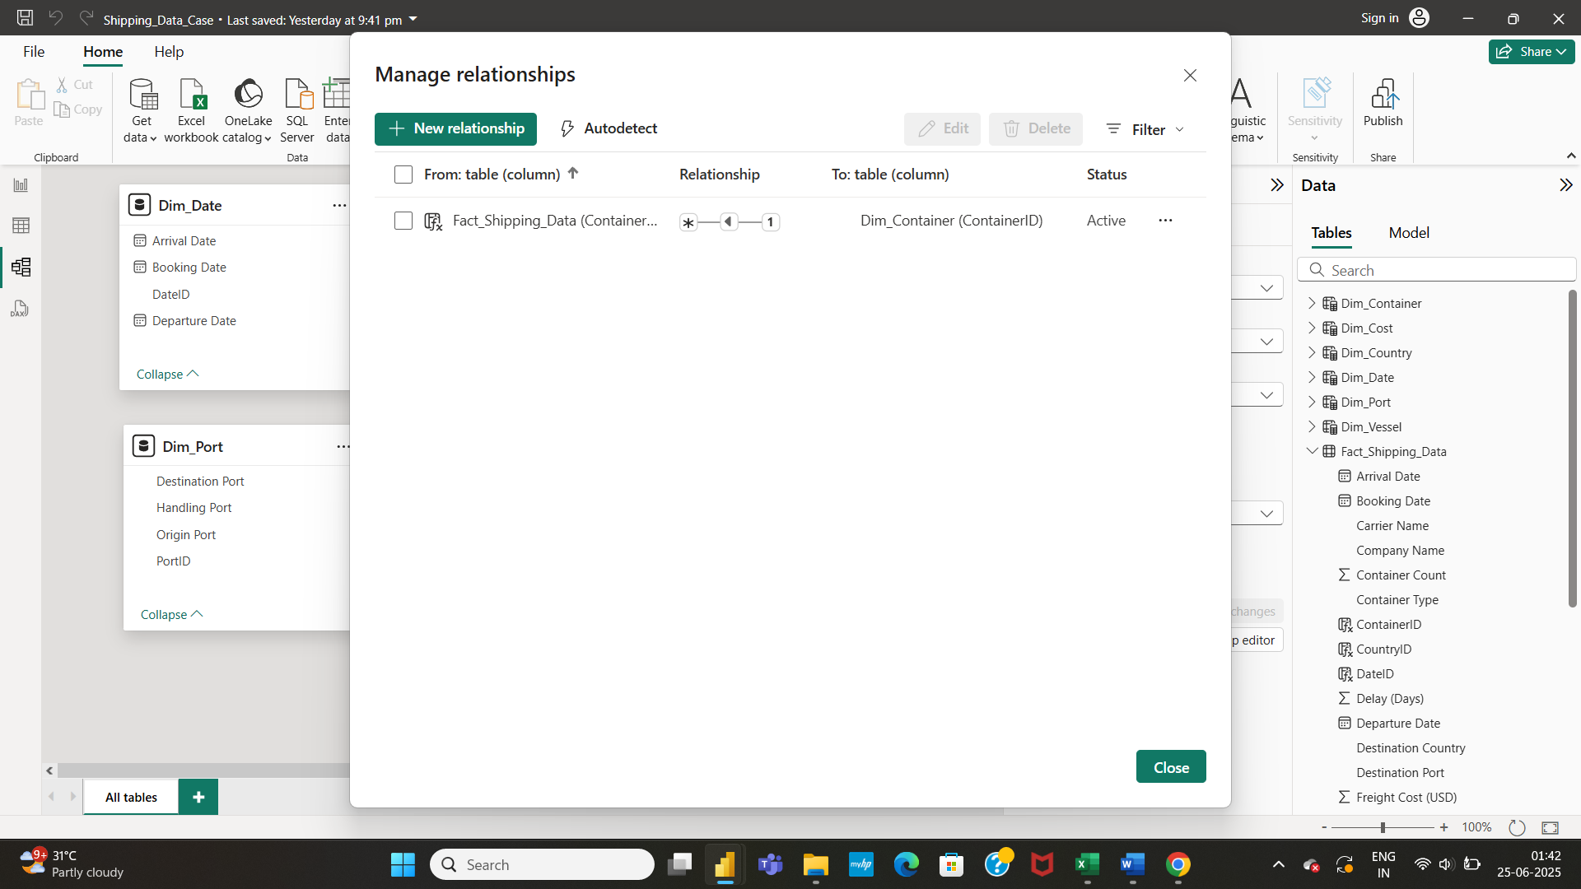

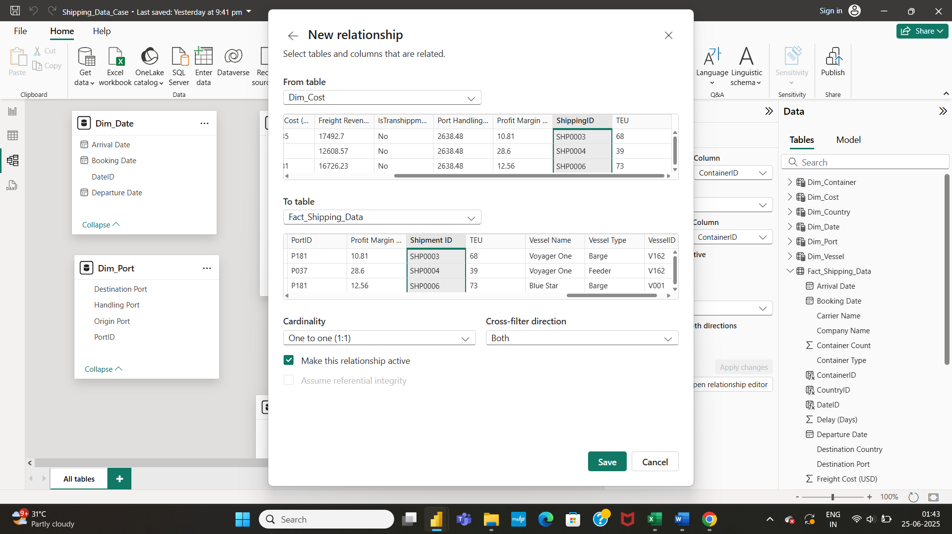

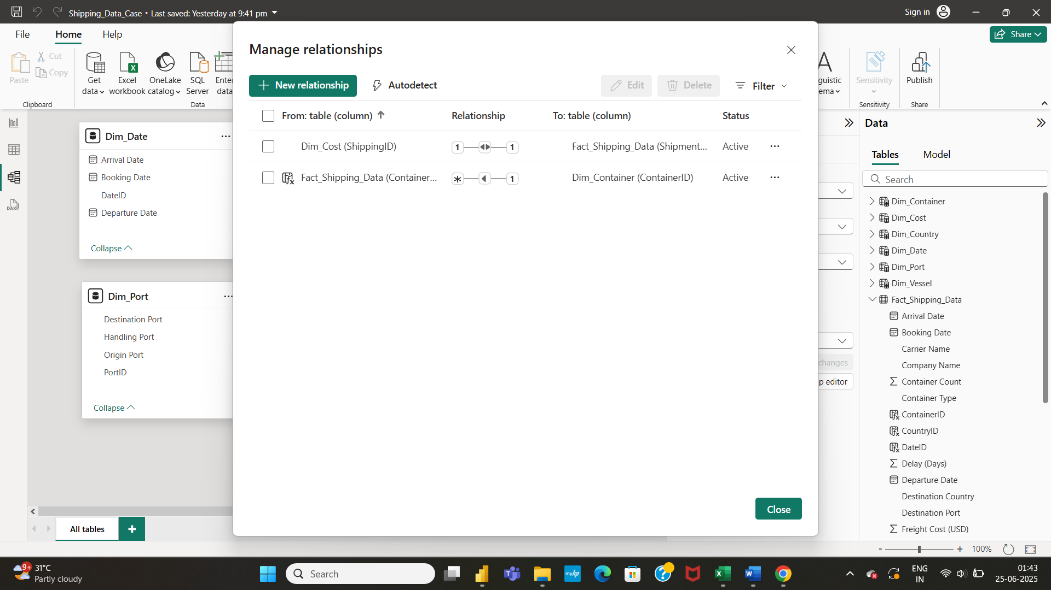

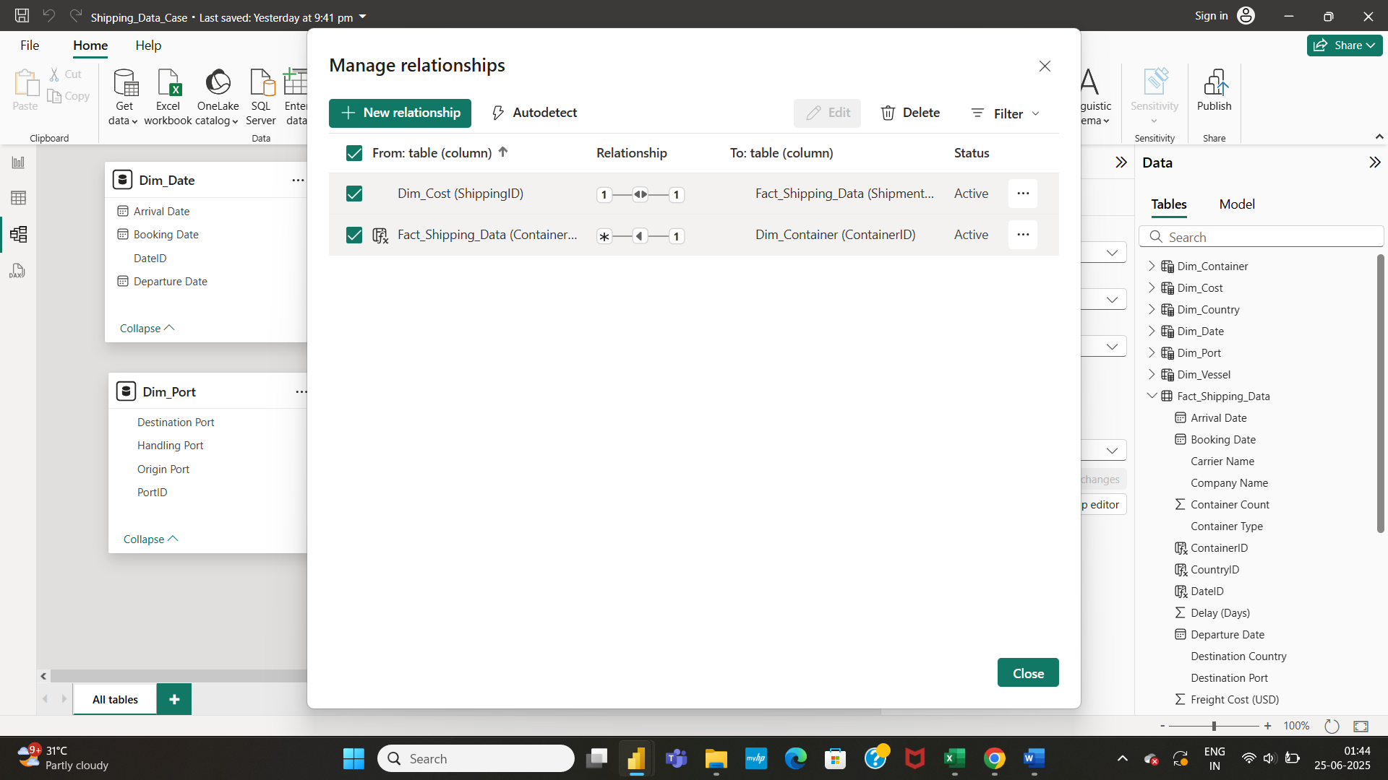

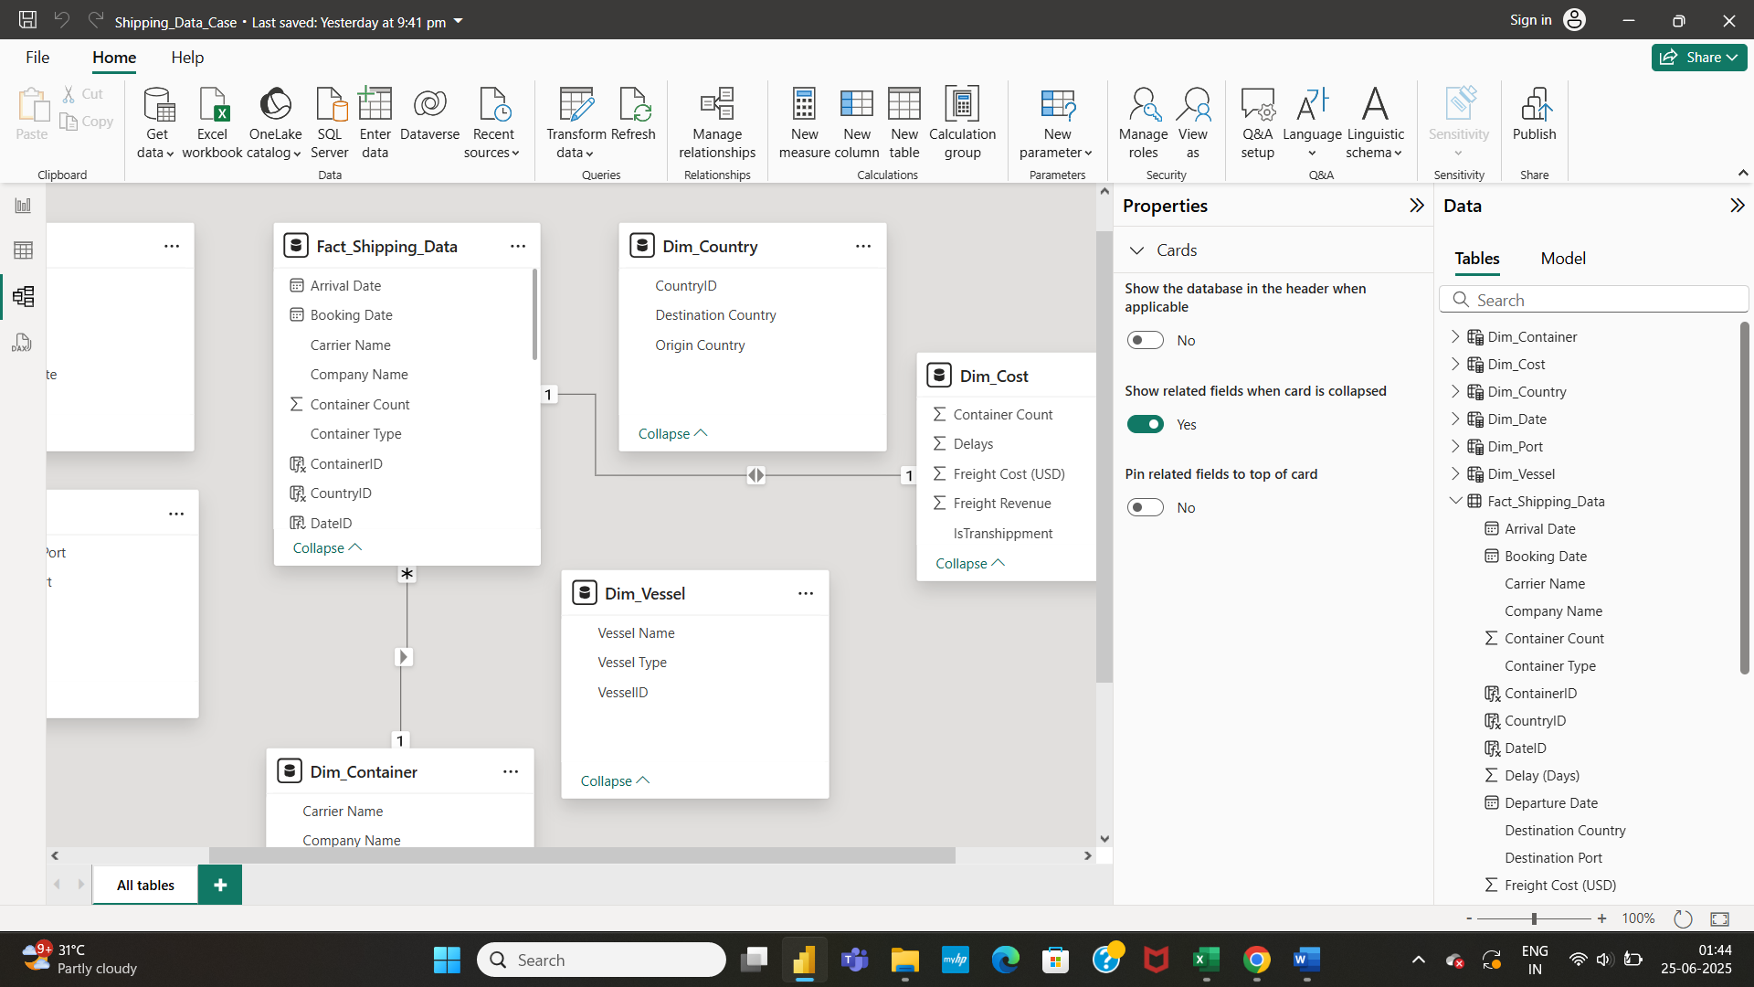

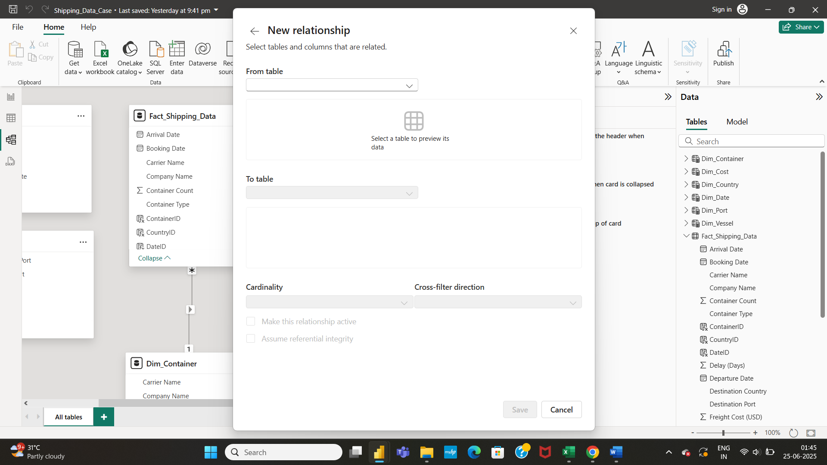

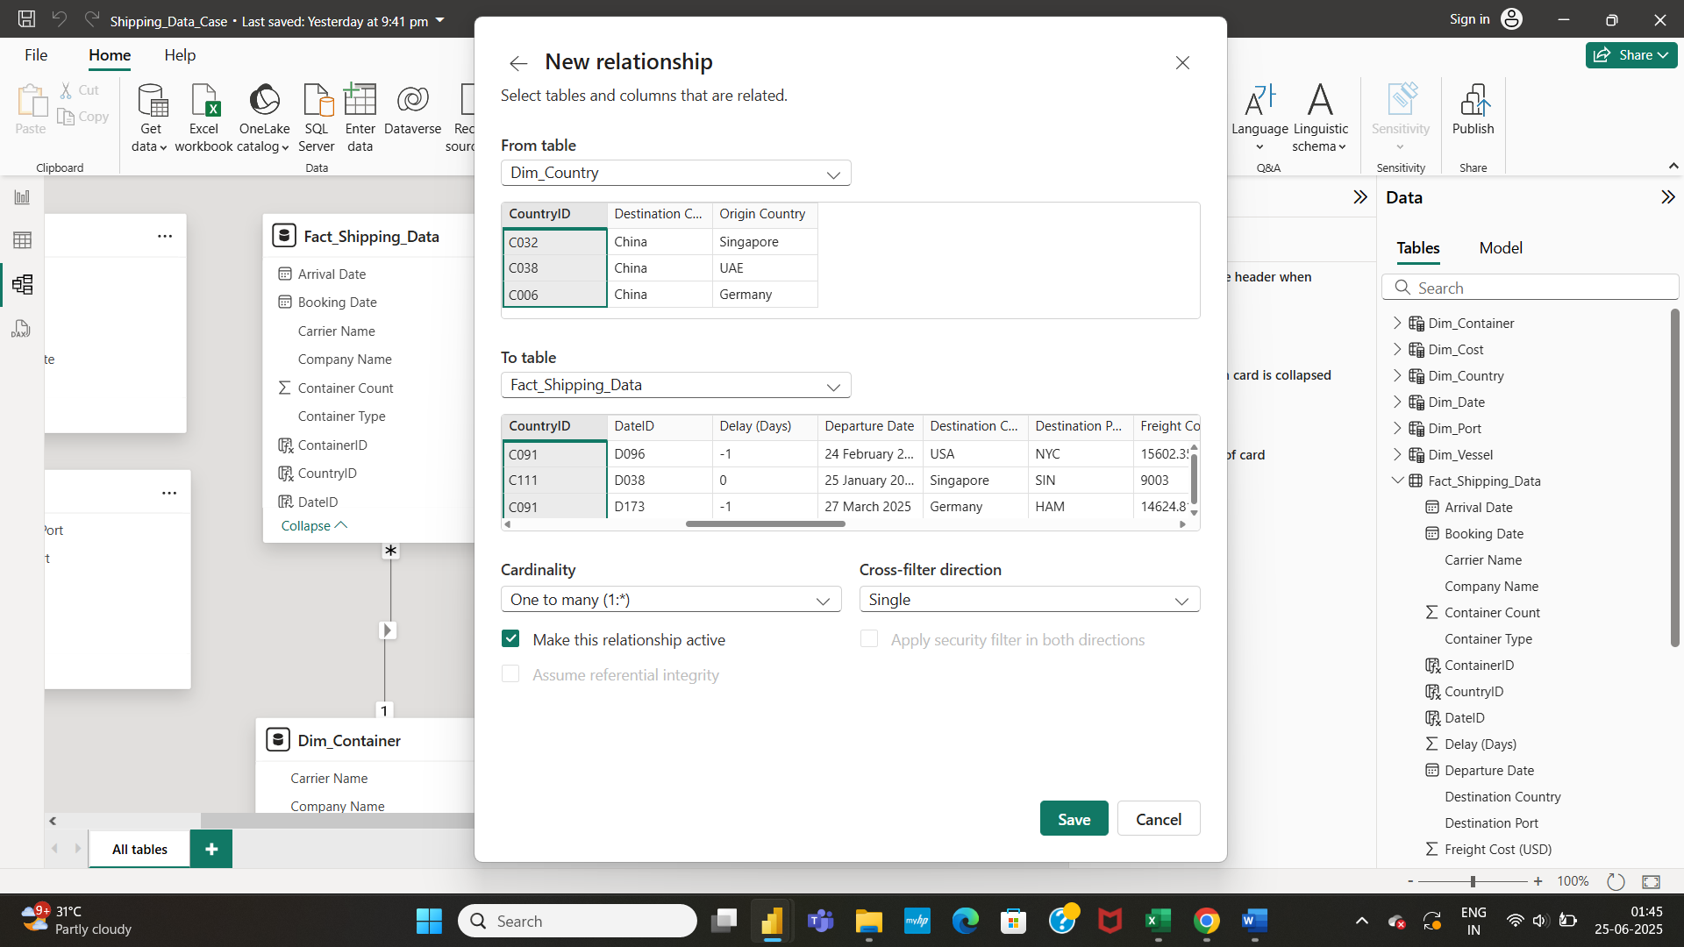

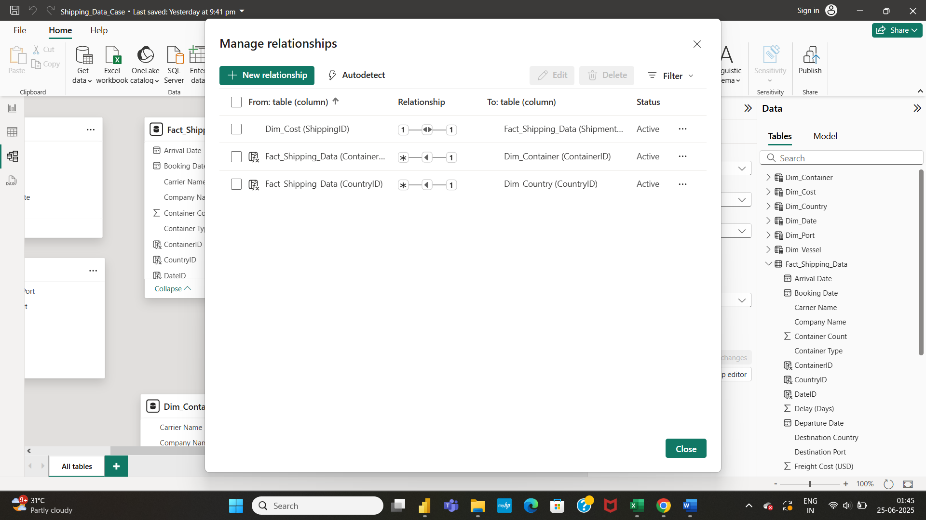

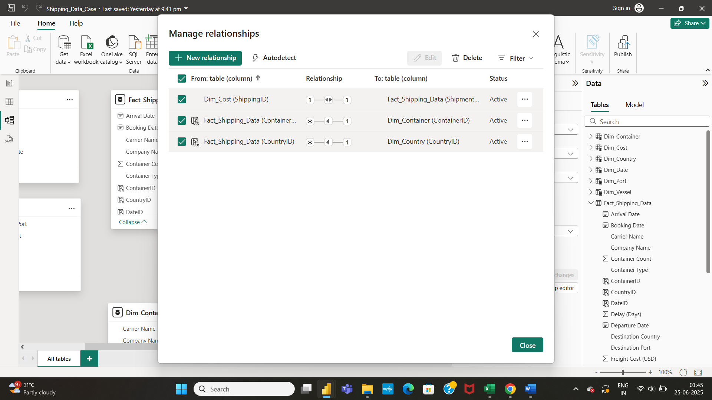

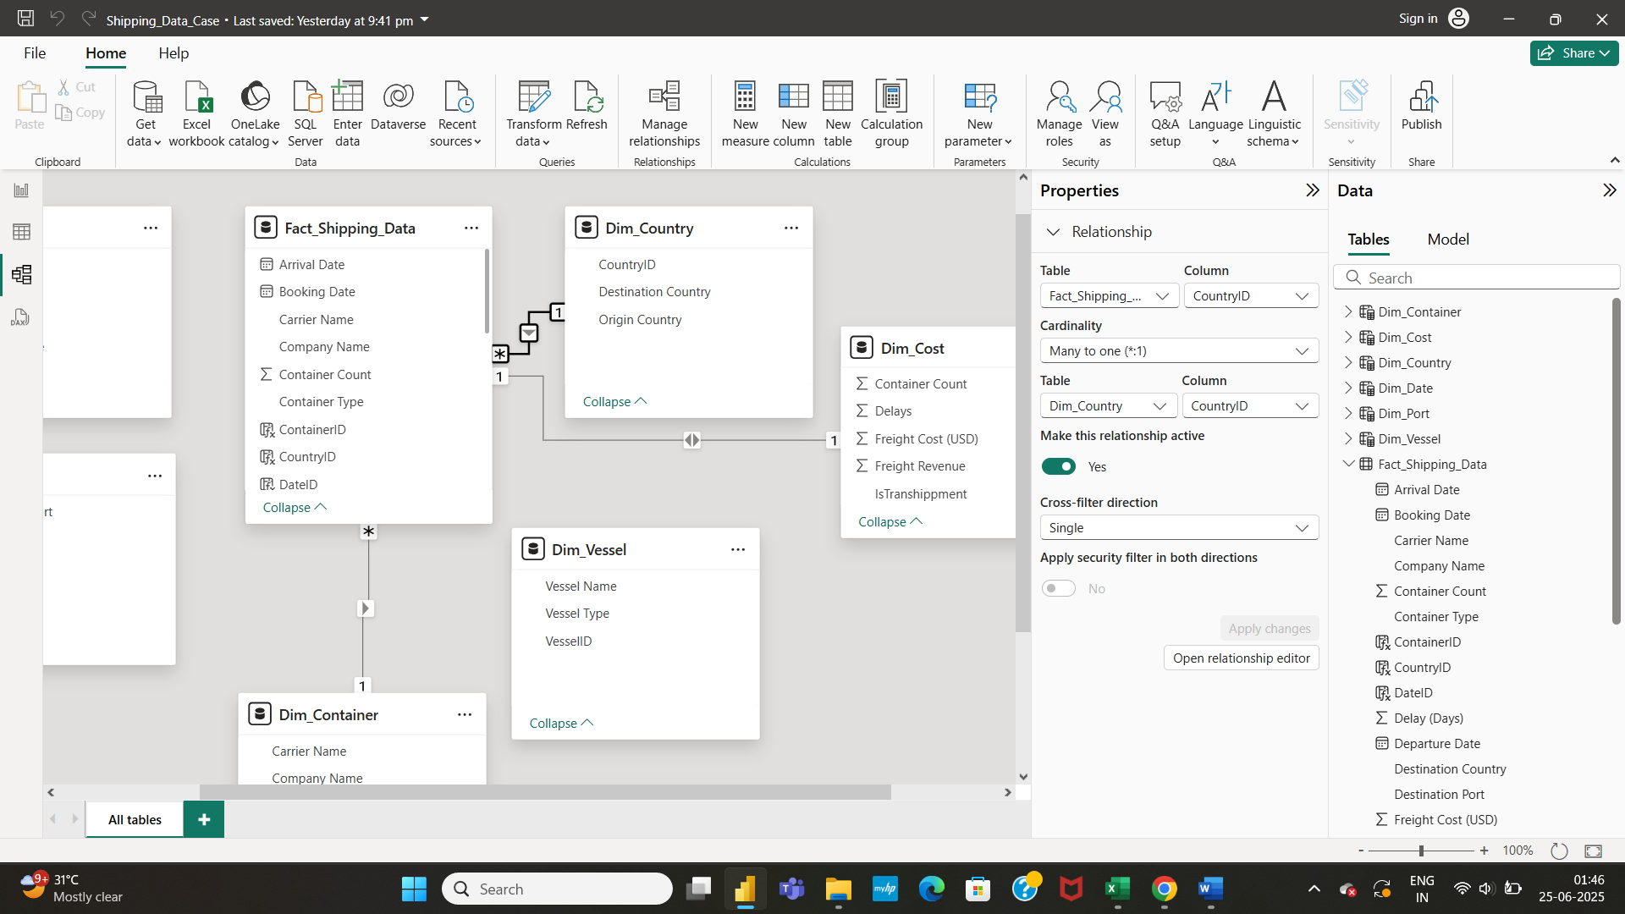

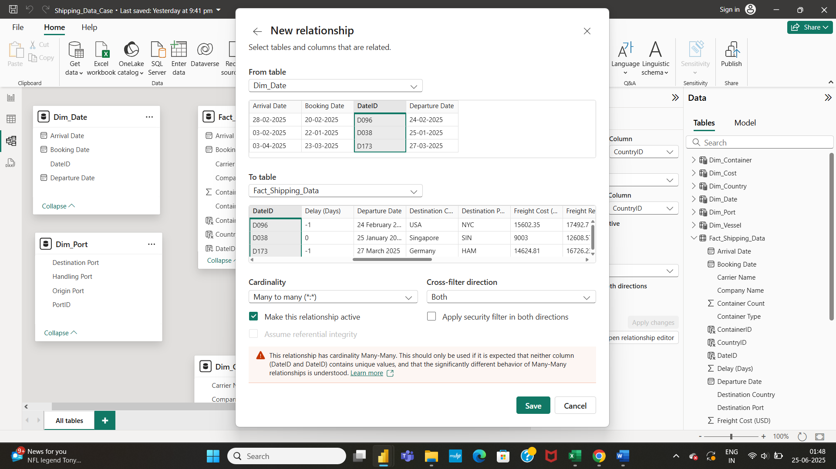

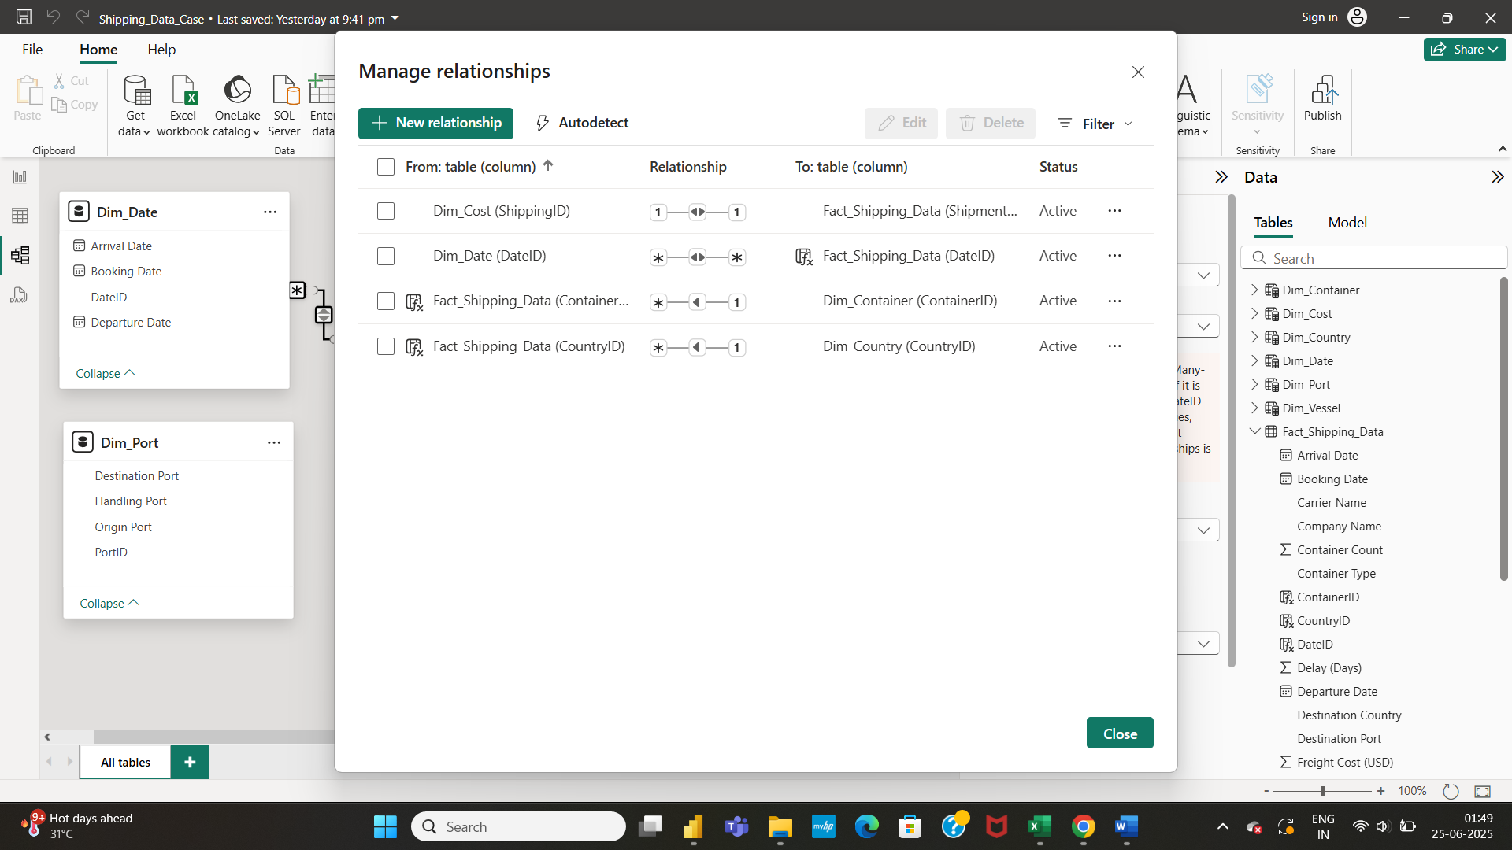

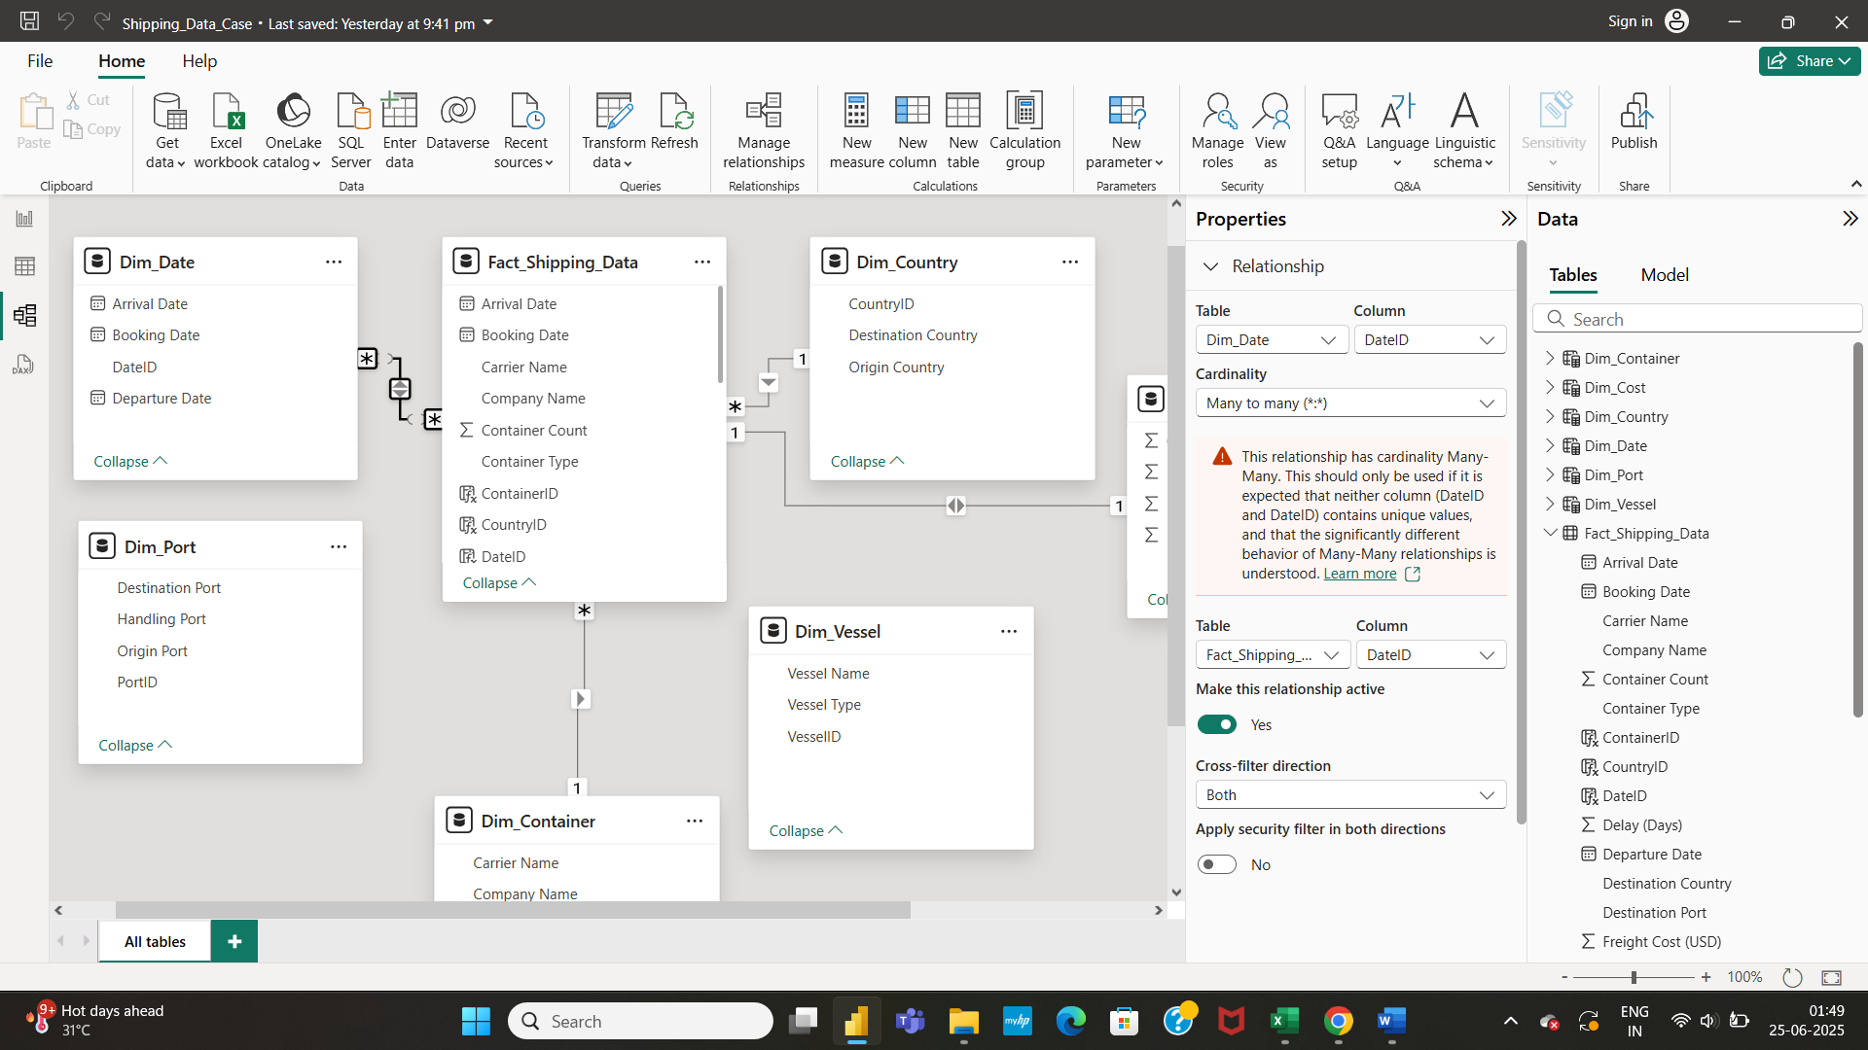

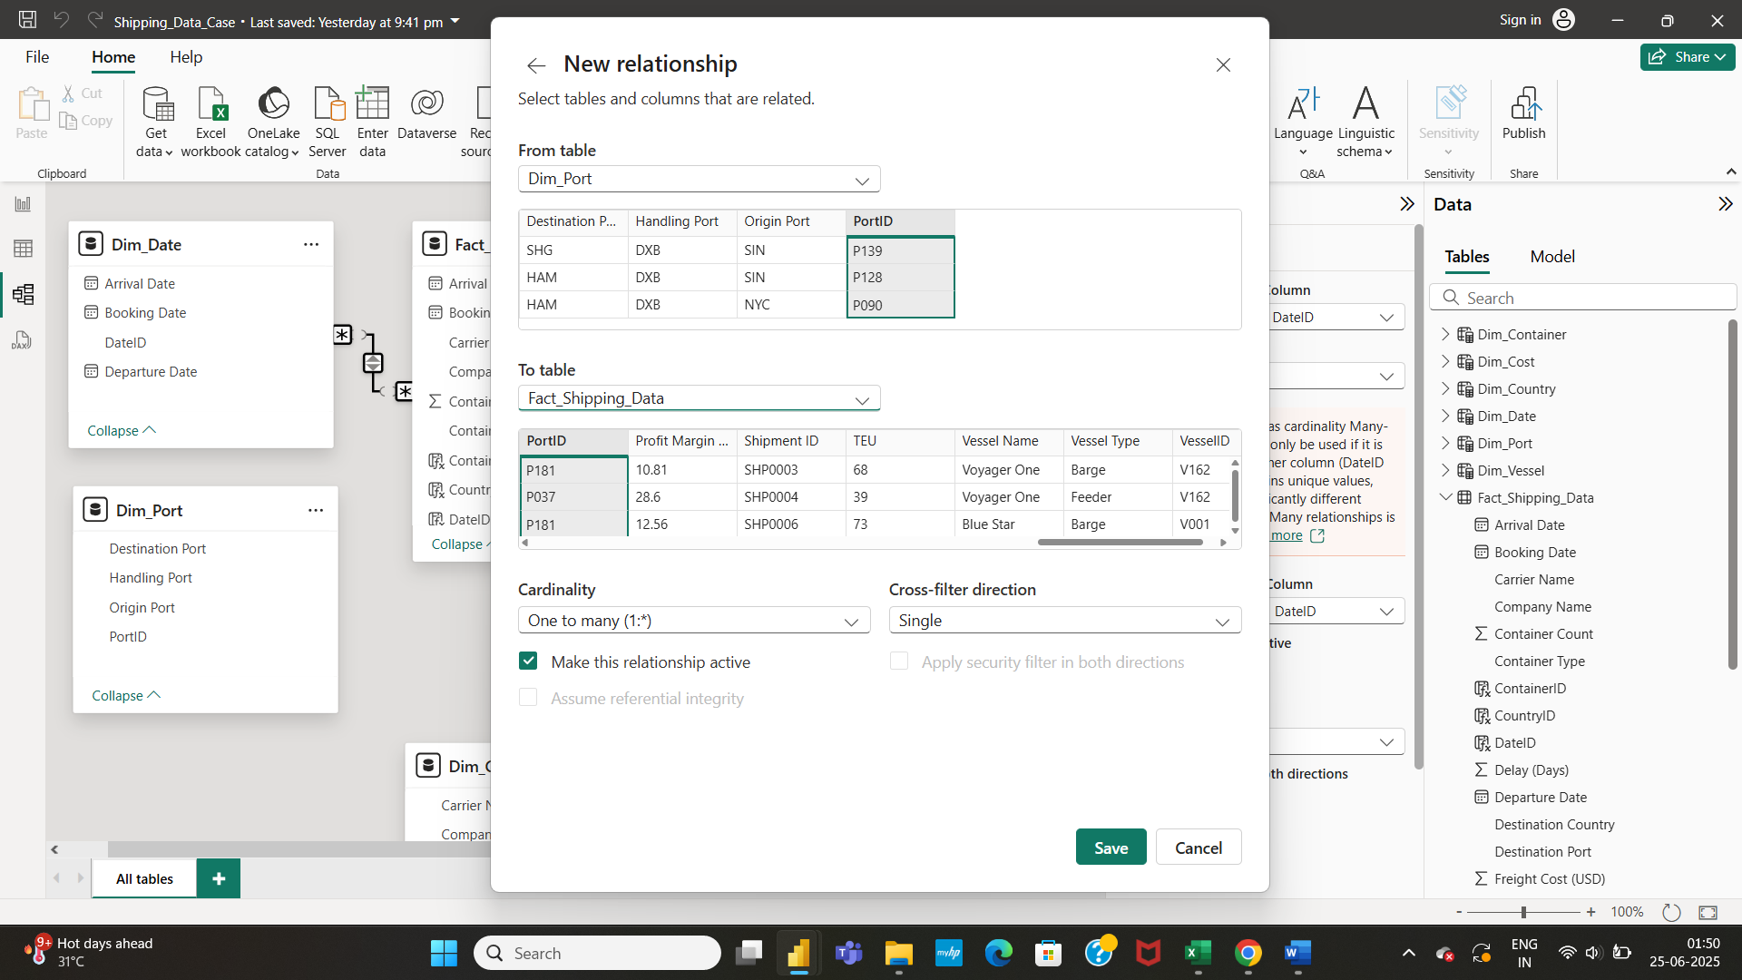

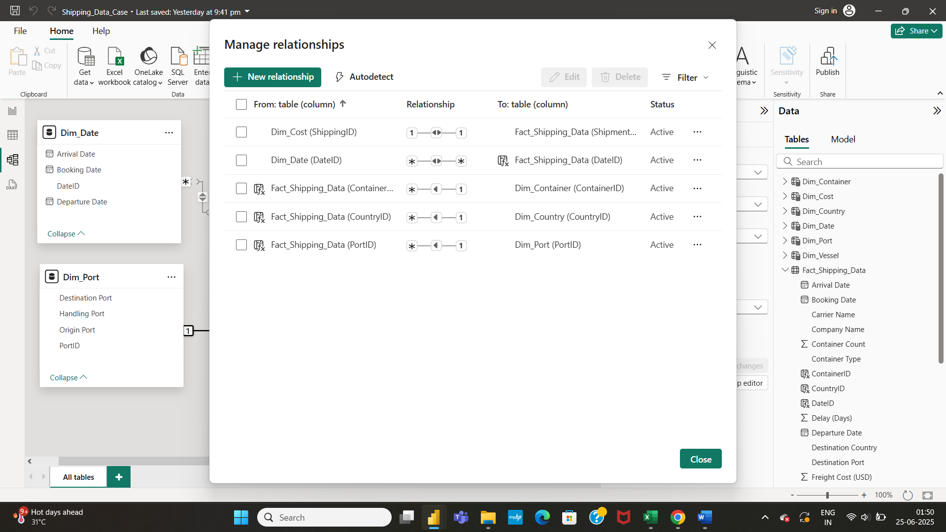

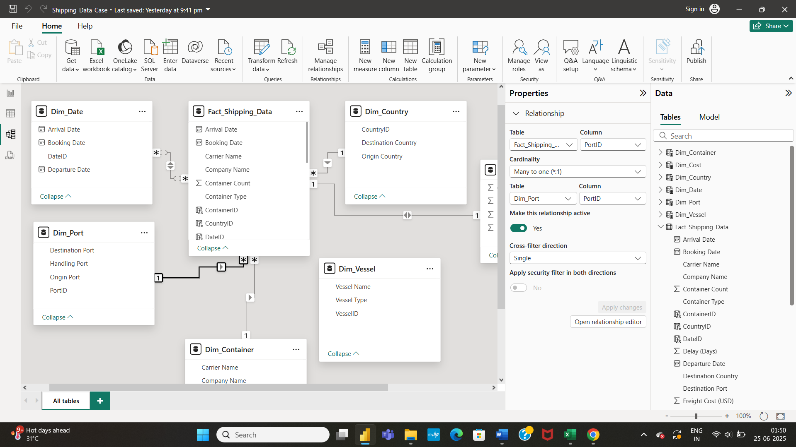

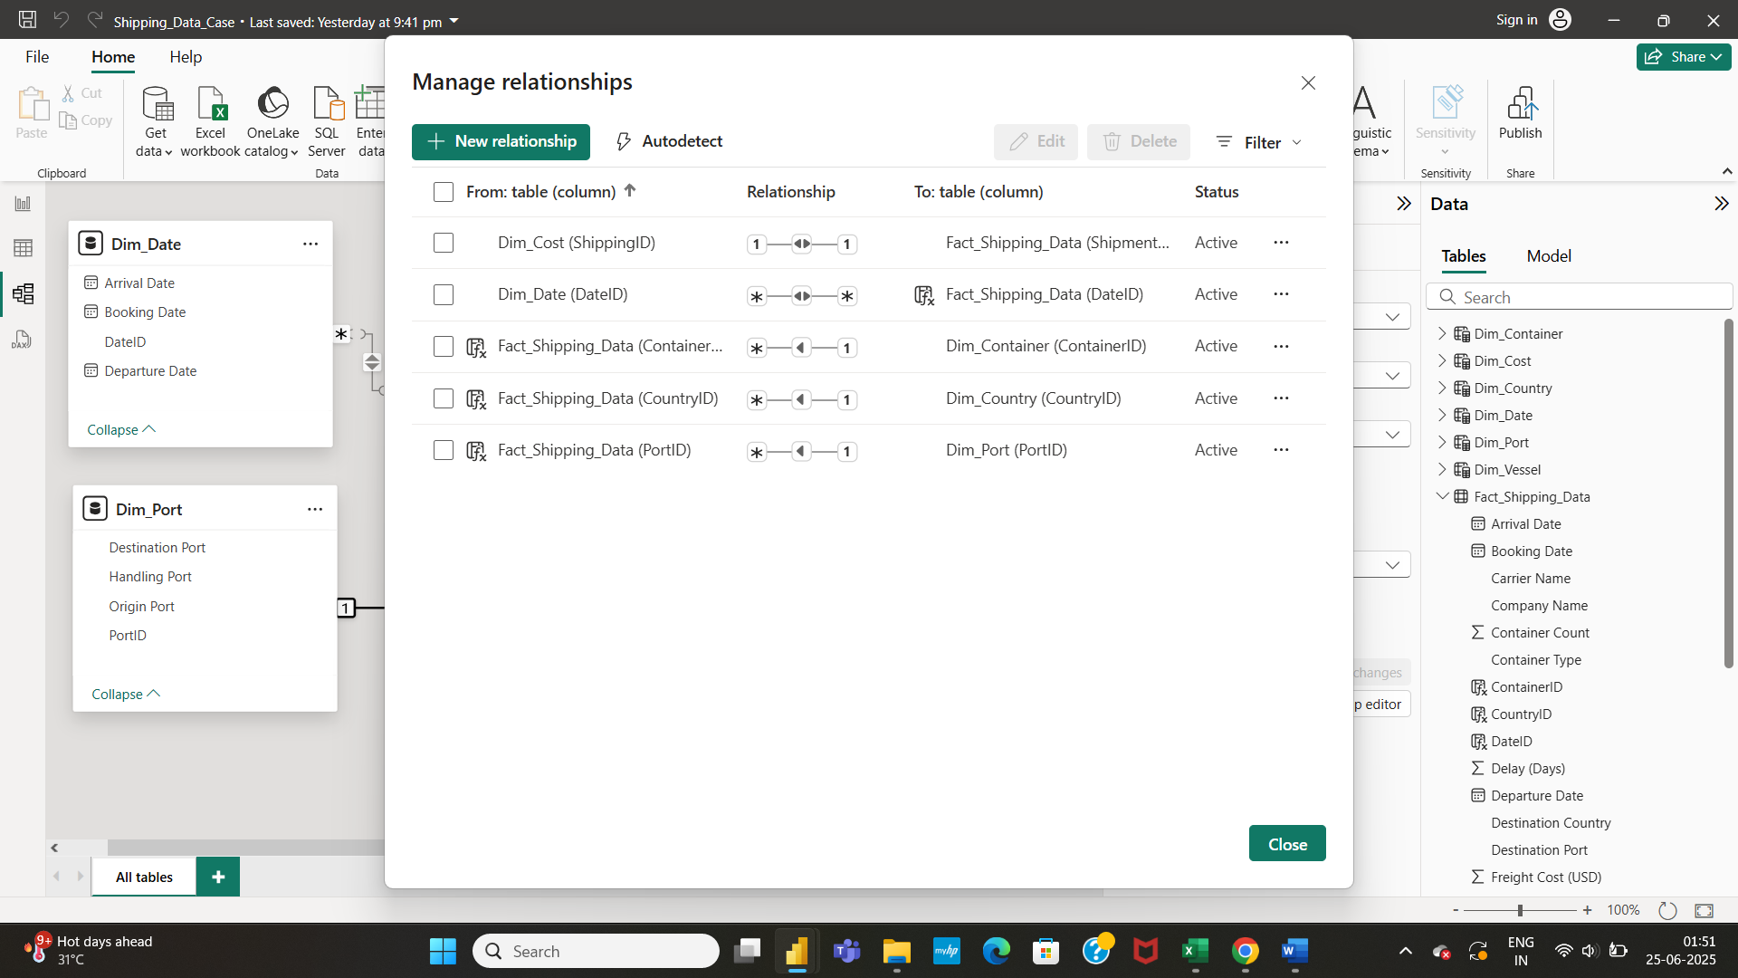

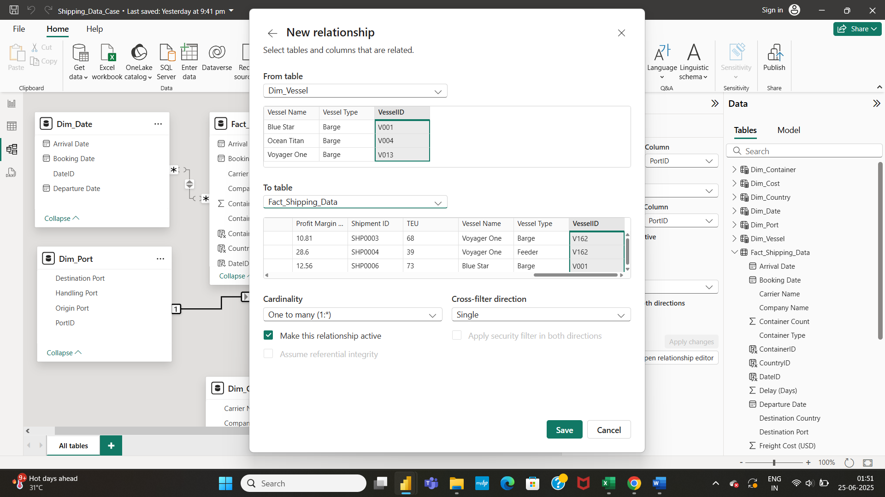

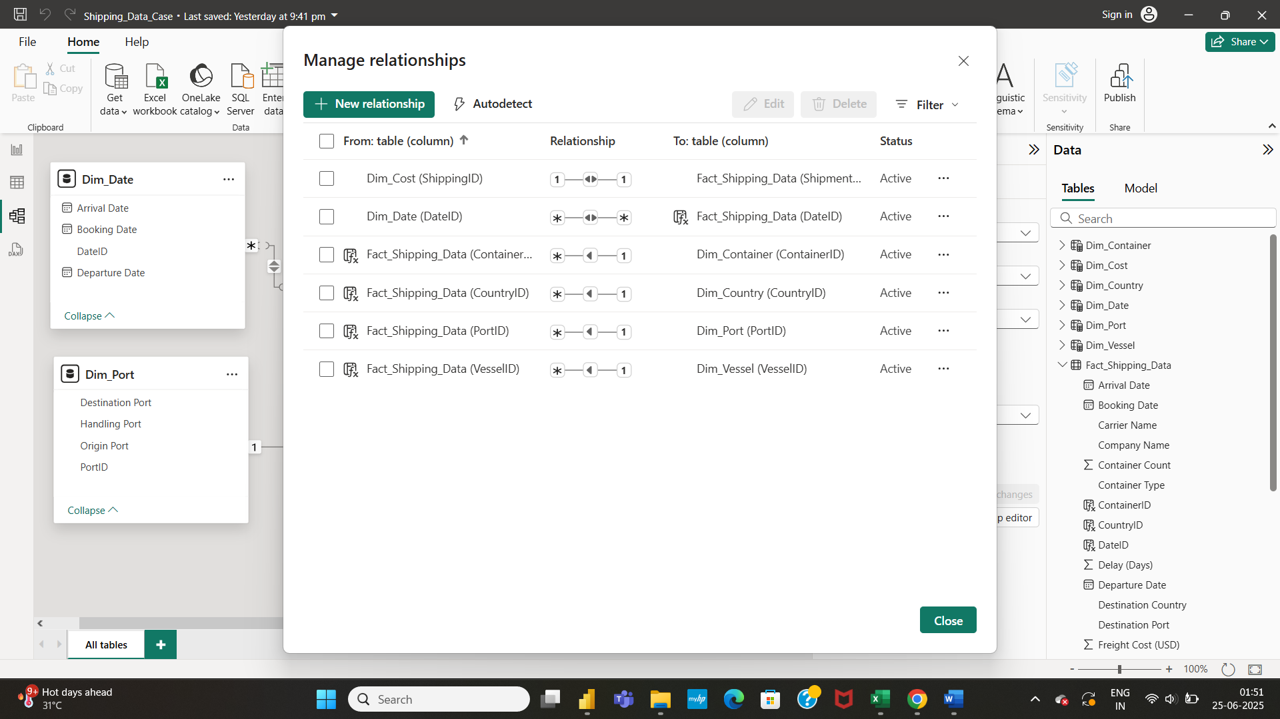

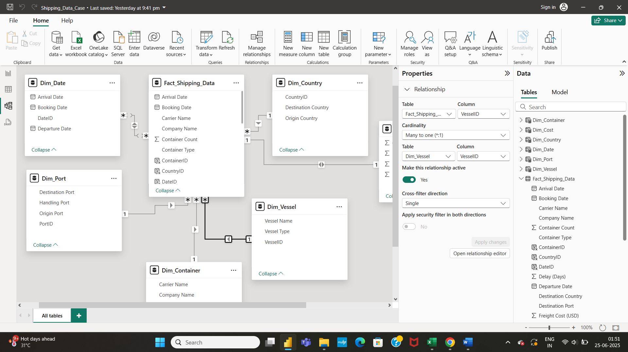

* Data modelling is done for the dataset.

**DATA VISUALIZATION:**

* I have created Line Chart for Number of Shipments booked as per Month, Line Chart for Number of Shipments arrived as per Month and Line Chart for Number of Shipments departed as per Month.
* Used Company Name as a separate slicer and Carrier name as a separate slicer.
* Slicers help to filter number of shipments as per company or number of shipments as per carrier.

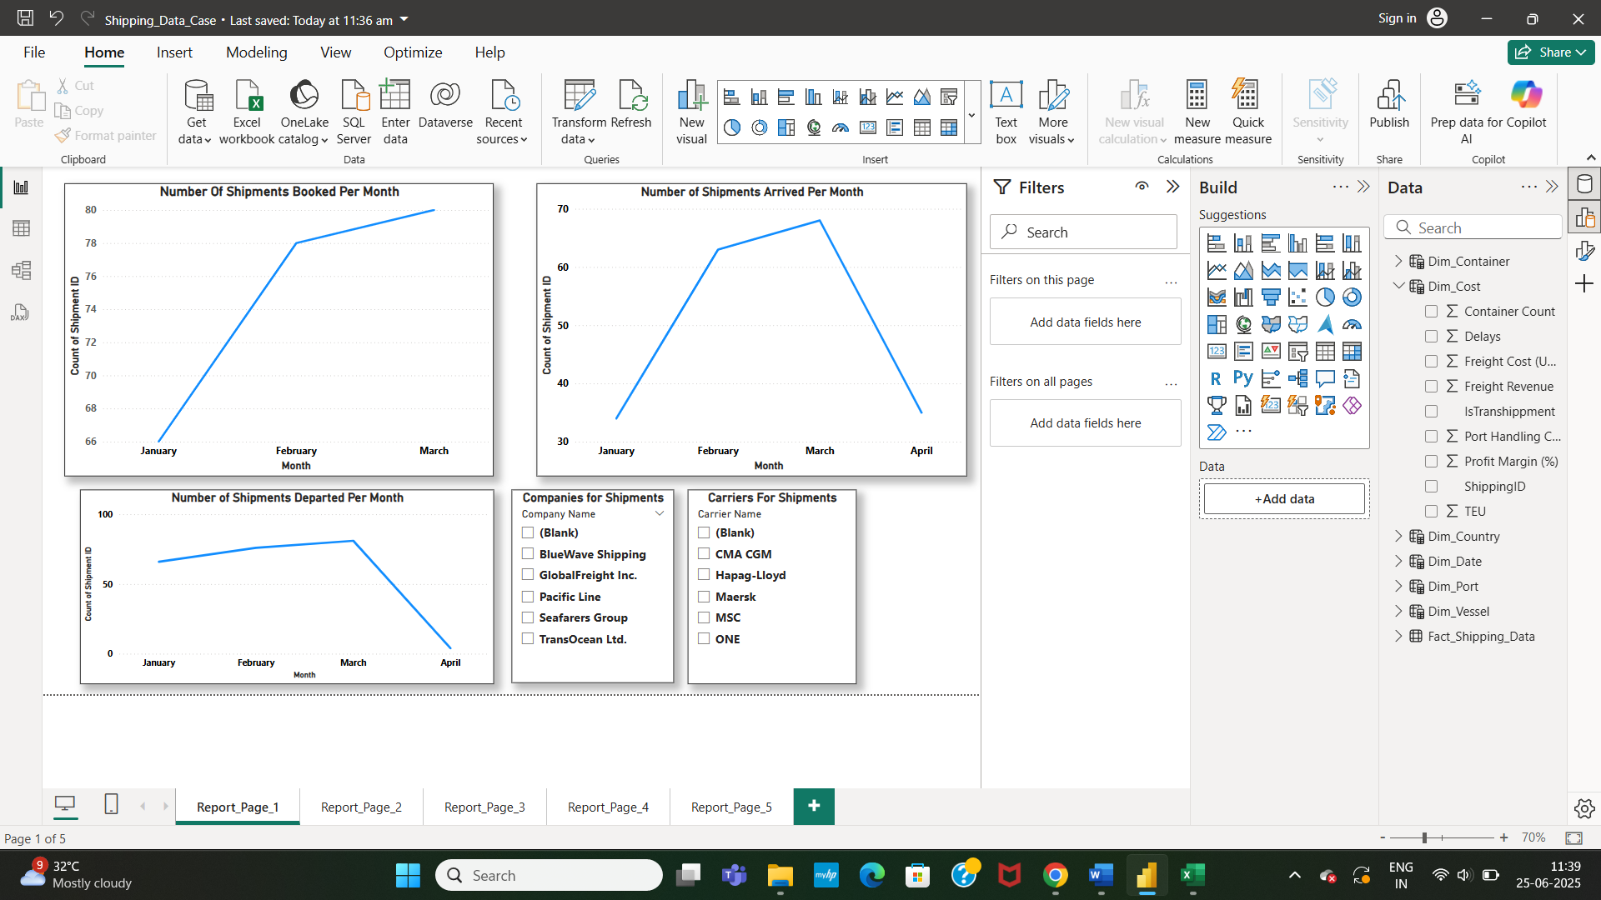

* Created Bar Chart to indicate number of origin ports, number of handling ports, number of destination ports. Created Area Chart to indicate Sum of Handling Port Cost (USD) By Handling Port.

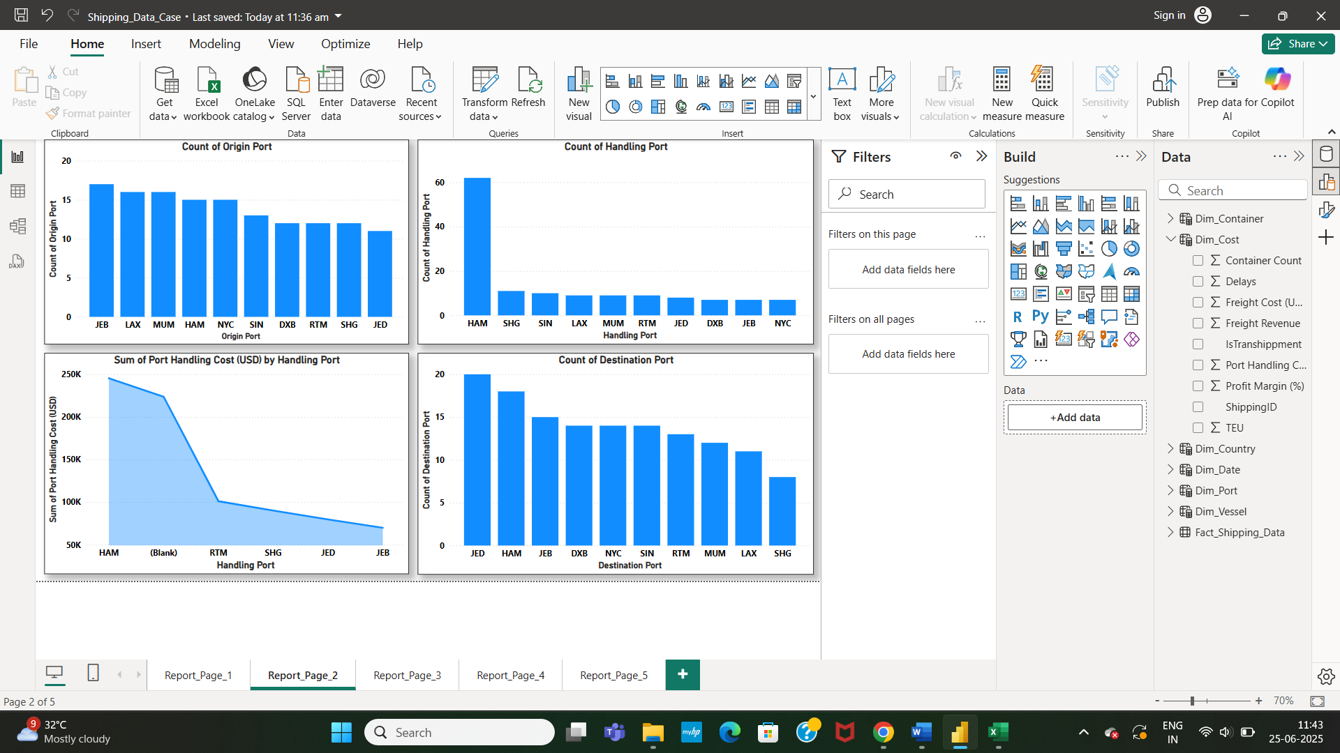

* Created Area Chart to indicate Shipment Volume By Month, Pie Chart to indicate percentage of carrier types used for shipment, Pie Chart to indicate percentage of company types used for shipment.
* Implemented Slicer for Container Type to filter shipment volume, percentage of carrier types and percentage of company types as per each Container type.
* Created Slicer for Vessel Type to filter shipment volume, percentage of carrier types and percentage of company types as per each Vessel type.

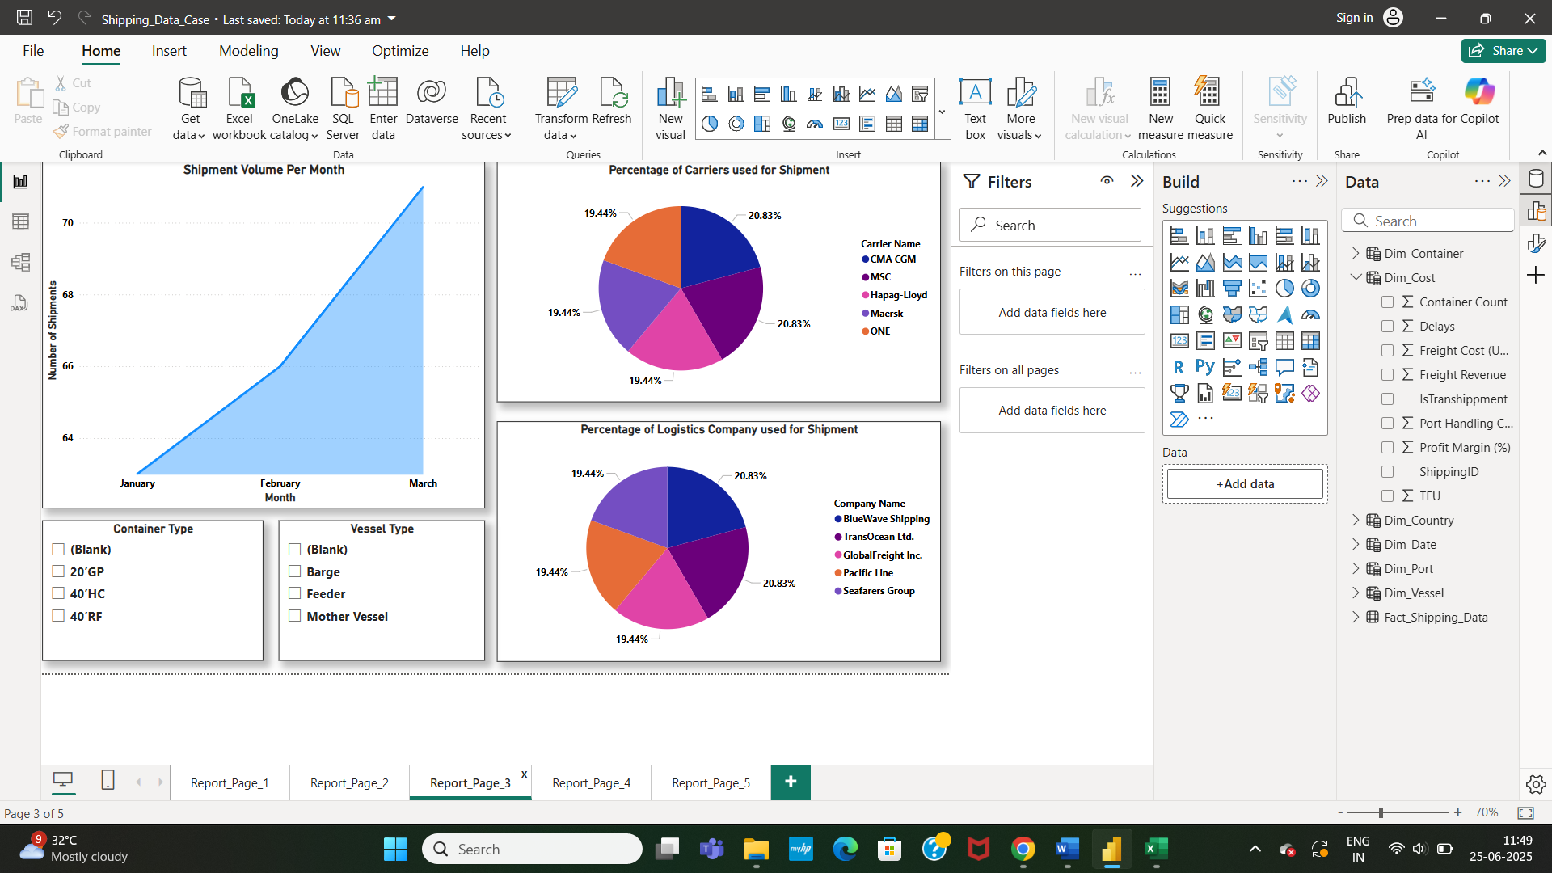

* Created Area Chart for Total Freight Revenue by Month, Area Chart for Total Freight Cost (USD) by Month.

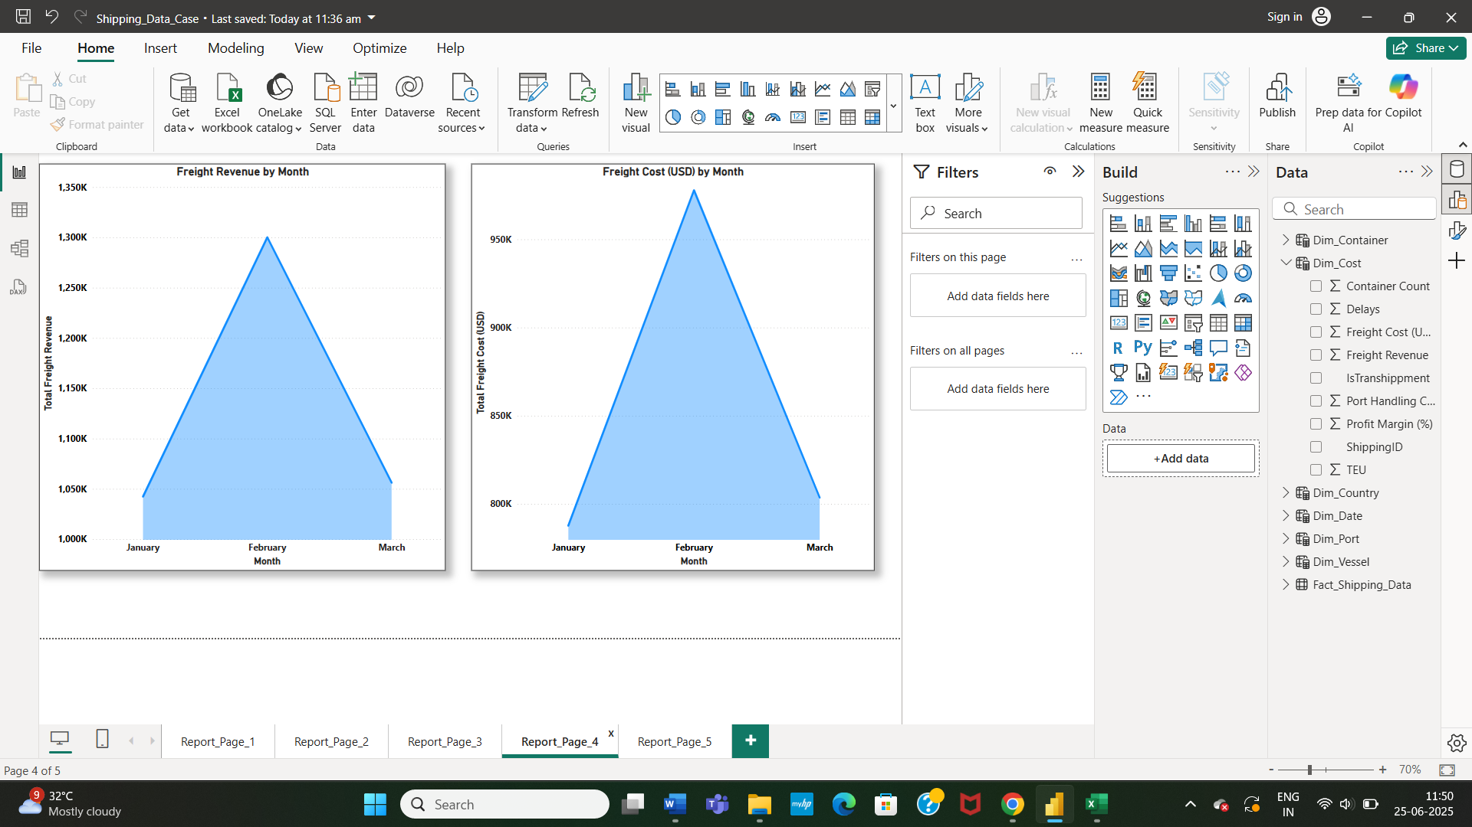

* Created Area Chart for Total Port Handling Cost (USD) by Month, Area Chart for Total Profit Margin (%) by Month.

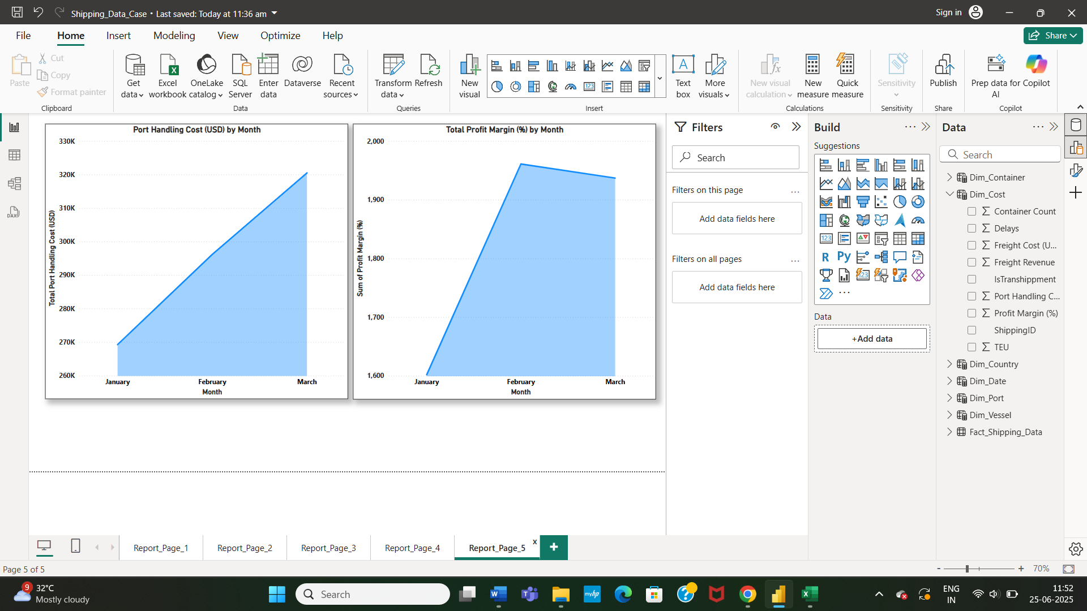

* A Power BI report is thus created from the Shipment Data. For Data Visualization (to perform of analysis of data using visuals), Data Modelling is mandatory. Inappropriate relationship establishment or inappropriate proper cross filter direction from one table to another table will lead to chaos in Data Visualization.
* I could not Publish this Power BI report created in the Power Bi Desktop to Power BI Service because of no work account present. I hope this document and Power BI report created would give insight about the Shipping Data.